-DRAFT- Personal Use Only

Cultural Communication between Arabs, Palestinians and Israelites
an application of Information Philosophy

© 2009, Johannes Cornelis van Nieuwkerk

Johannes Cornelis van Nieuwkerk
P.O. Box 275
3000 AG Rotterdam
The Netherlands
GSM: +423 663 019 190/+36 20 9877082

Email: jcn@informationphilosophy.com
Cultural communication between Arabs, Palestinians and Israelites; an application of Information Philosophy

Preface and Disclaimer

This article is about cultural communication and non-communication between countries or people. From its theoretical side it is based on twenty years of research, on its implementation side it still is one of the first attempts to put an observation based theory into practice however. What is described below is not about truth, it is about finding truth. Field research has (out of a lack of funds) been very limited and assumptions have been mainly made on the basis of limited media exposure.

Information Philosophy uses personal observation and participation as its basis. The valuable “broader” type of results this generates do not match well with the much greater level of detail other methodologies offer. Therefore on purpose no literature research has been done. This is of course a very risky and slippery approach with questionable value from a traditional science point of view; it however generates another perspective. The result is a macro comparison between countries; an illustration of the practical way momentary communication can be recognized and dynamic scenarios for improvement can be generated without any historical ballast.

Information Philosophy’s horizon is to generate an “approximate” starting point to zoom-in from. Its real goal is to stimulate people to create their own starting-points, using their own vision and assumptions. Doing so will correct the possible errors made in the preliminary assumptions. Therefore at this stage there is no target to come with any conclusive or final results.

Information Philosophy mapping is based on generalization, it tries to determine the fundamental balance between three communication methods people possess. Although individual people are far from equal and their communication widely varies, on a micro, meso and macro level people still must be able to recognize each other and to properly exchange messages. The way this is organized is strongly coded in every society or culture; this is why Information Philosophy uses it as its foundation.

What are the three communication methods or dimensions? The first dimension is rational communication; it is a question answer based method of argumentation. The second dimension is emotional communication; it is a temperature based method of association. Finally the third dimension is spiritual communication; it is a “waiting for consensus or orders”, silence, based method of contemplation or meditation.

The three methods or dimensions are dipoles. At one end of the scale there is open communication with everyone, at the opposite end there is restricted, exclusive or non-communication.
As a result there are six cultural communication elements defined:
Restricted (Identity) Open (Unity) Abbreviations
Rational: -1- Individuality -2- Interactivity -1- II -2- IU
Emotional: -3- Rivalry -4- Collectivity -3- EI -4- EU
Spiritual: -5- Superiority -6- Religiosity -5- SI -6- SU
(II and IU are abbreviations of respectively Individual Identity and Individual Unity)

Every culture uses two elements as its basis of which one dominates the other. There is also tension between the two elements, meaning that a culture is always changing into a certain direction, either moving towards or away from its dominant element. Forces are counterbalanced however; dominance and direction can change. Cultural dynamics are an end result.

Cultural dynamics are universal; their influence can be found on individual (micro), group (meso) and on country or culture as an entity (macro) level. Examples in this article rather select the most clearly recognizable level and are not harmonized in this respect. Often multiple examples are used.

An important related factor is the nature of the dynamics. The dynamics can be either Assertive or self-determined or can be an Adaptive result of external circumstances. Every dynamic direction, moving away or towards a cultural element, has two assertive and two adaptive connections balancing the element in relation to the other connected cultural elements. It implies that if one assertively travels towards another element, the return path will be adaptive. If the traveling towards another element was adaptive, the return will be assertive. The nature of the dynamics is important if one wants to stimulate change; adaptive developments can only be indirectly influenced and are more difficult to stimulate.

Although every culture uses only two elements as its internal basis, it has an external “neighboring” relationship with all other elements. These external relationships are fully determined by the dynamics or direction in which the balance between the two basic or internal elements is changing. The external relationships follow the same direction toward/from the poles. It means that if one can identify the internal elements and their balance, one can also automatically predict the external relationships of a culture.

To some extend one can often even predict the role or strength of the external neighboring relationships. Their importance mainly depends on three factors. The first factor is whether the culture has an external element in common with one of its neighboring cultures? If not; the component will be relatively weak and underdeveloped. The second factor has to do with the general level of influence two neighboring cultures have on each other? A “powerful” big neighbor will likely have more impact than a “weaker” smaller one. The last, third, factor is related to whether the external relationship connects to a dominant or to a non-dominant internal element? The external influence will be stronger if the neighboring force connects to a dominant internal element instead of to a non-dominant one.
Next to the directly connected neighboring relationships there is one more cultural force defined in Information Philosophy. This component is related to the dominant factor. In order to establish clear communications, this factor mostly clearly outweighs its counter balancing force. Since the weaker counter balancing return, is in that case no longer a viable option (one is not supposed to return), the opposite pole starts to have a certain “the grass is always greener at the other side of the fence” type of attraction. This is a revolutionary rather than an evolutionary component; it will only in exceptional cases (like crisis situations that destabilize a culture and increase its dynamics) have its, in that case, major impact.

For a more extensive explanation of the mapping methodology an article named: Information Philosophy, Introduction, Mapping Cultural Communication can be downloaded from www.informationphilosophy.com.

A final major issue in Information Philosophy is the exact definition of the often very abstract philosophical information processing concepts. Although a lot of effort has been made to find as precise as possible words to label the processes, people often have their own reference to and interpretation of such words. Therefore in order to increase the preciseness two angles of view are used in this article. Maps are shown in both an institutional as well as in a personal angle of view version. These views are fundamentally identical but contain label synonyms.

Of course readers likely would often have used their own personal and different words to label processes. They still can feel free, and are actually invited, to do so because this hardly impacts the philosophical reflection. Labels are merely used to differentiate between processing options; their main purpose is to keep overview of the total and not to describe an individual option in detail.

The result of Information Philosophy is the possibility to zoom-in to local situations and to analyze the local balance of forces. This outcome must be interpreted with great care however, since it only shows “stereotype” behavior. Still, regardless of individual freedom, most people remain strongly influenced by their cultural environment. This is why mapping their cultural expectations in respect to processing and communicating information makes sense. It is a good indicator for understanding or misunderstanding each other.

The remaining article has the following structure: First “leadership based Arab”, Palestinian and Israeli culture will be mapped and discussed separately. Next, the current communication between the three will be described. Finally potential cultural change and migration scenarios that could improve the cultural communication will be discussed.

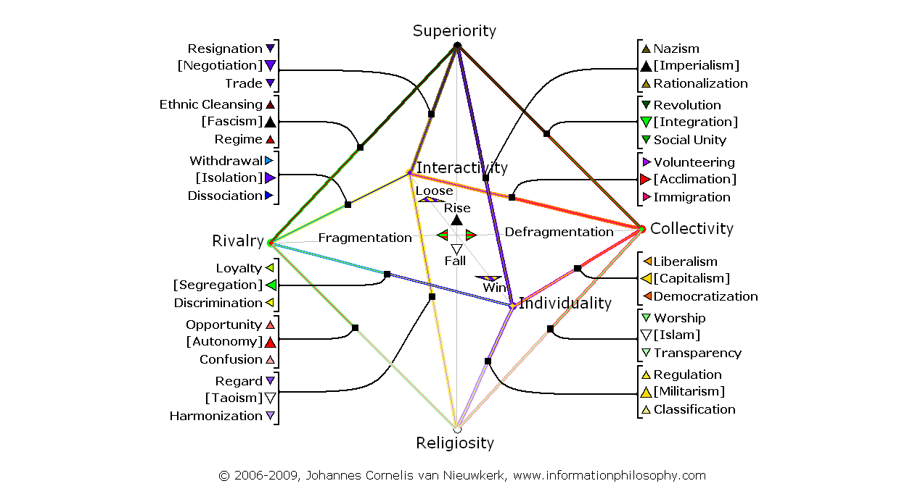
Map 1, Information Philosophy, All Main+Detailed Assertive Processes, Institutional View:

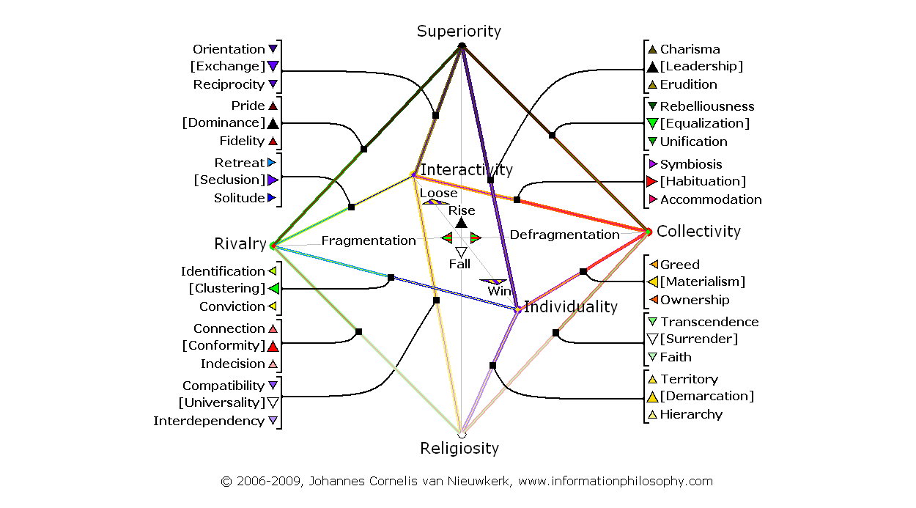
Map 2, Information Philosophy, All Main+Detailed Assertive Processes, Personal View:

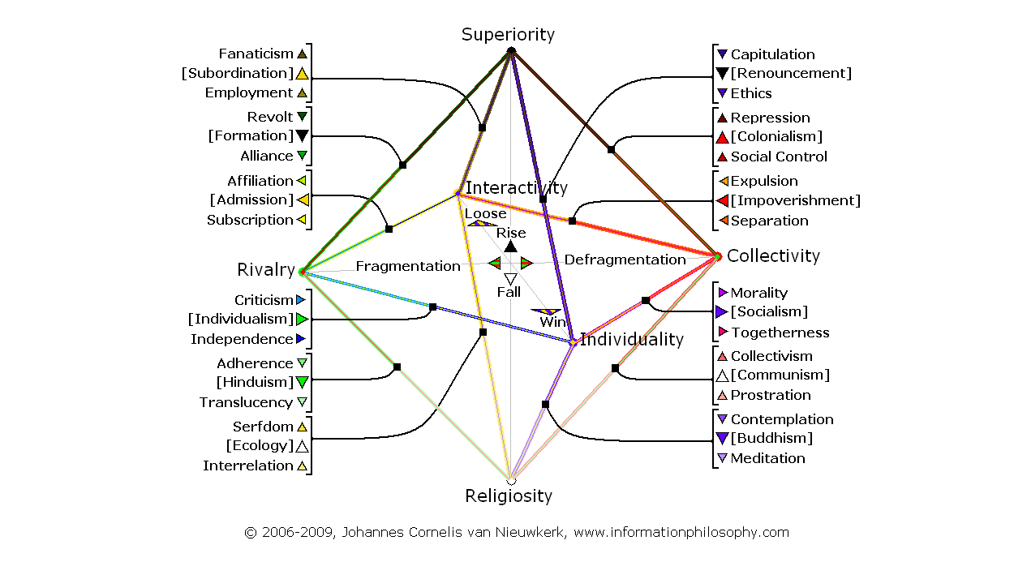
Map 3, Information Philosophy, All Main+Detailed Adaptive Processes, Institutional View:

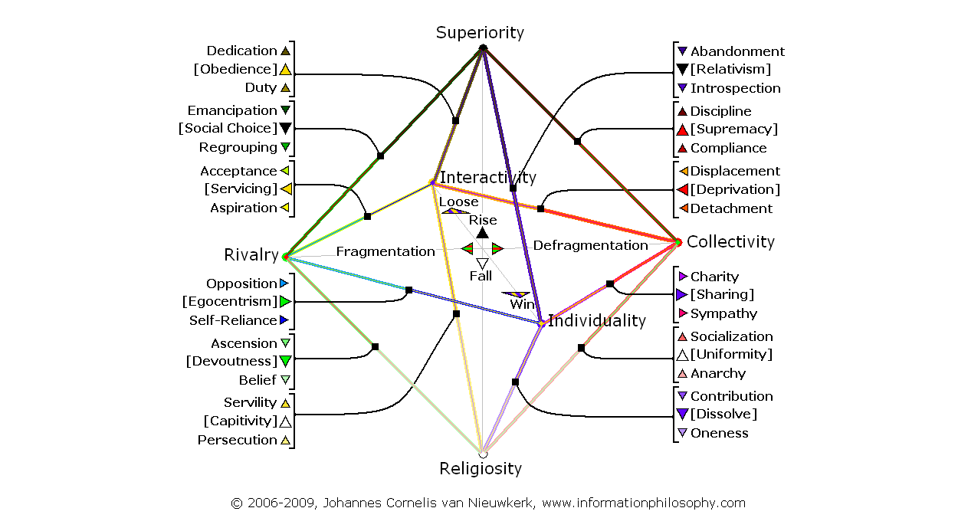
Map 4, Information Philosophy, All Main+Detailed Adaptive Processes, Personal View:

Leadership based Arab culture

Looking at information processing, Arab cultures have association as their basis. The personal relationship between people is dominantly emotional and temperature based. The type of emotion is open; in principle other people are considered to be friends, welcomed and invited. People are not principally excluded, only people that refuse the invitation and its related call for and obligation to assimilate are excluded. This exclusion however is strict and can be violent; there is no cultural space for any other identity.

The second component is a spiritual component. Arab cultures possess in general a relatively weak individual(istic) component. Instead, the spiritual component is structuring the general collectiveness of the culture. The way the culture is structured varies from country to country. In most countries it is “adaptively” (meaning that the people adapt to a given leader superiority without much influence of determining it) structured by strong leaders that dominate the culture. The type of leadership is “primus inter pares”, meaning that the leader represent the general interest of the population (or himself) and not primarily the interest of any ethnic fraction at the cost of others. Leadership is strong and results in social control with in many cases elements of repression. People have to be personally compliant to the culture and are forced into strict discipline. Levels vary however. In most Arab countries repression is not dominant. Some countries are different and follow an “assertive” (meaning that the people actively and voluntarily participate) Islam based approach in which Allah also dominates worldly leadership and in which the emotional dominant society is structured by religion and worship and not by individual superiority based human leadership.

Up till now, Arab culture citizens do neither reject their strong leadership structure nor does a communist approach of sharing property outweigh the influence of Islam. This indicates that Arab cultures travel into the direction of spirituality and away from emotionality and not the other way around. It means that the external relationships of the Arab cultures are based on this.

In most “human leadership dominant” Arab countries the external relationship with Religiosity remains very strong. It is Islam worship and individual transcendence based. In some countries this component is even so strong that it represents an internal component. Where this is the case, the human (Superiority based) leadership component becomes an external instead of an internal component. Mainstream Arab culture is however dominantly individual human leadership based and this positioning will be used for the rest of this article.

Next to the relationship with Religiosity there are two external relationships with rationality. In relation with Individuality, personal property, materialism and democratization are accepted. At the other side of the scale do deprived or impoverished (Interactivity based) people face a certain level of separation or detachment. The issue of the positioning of individuals in relation to the group does however not dominate culture. Collectivity is clearly more important; individuals remain strongly linked.

Weaker external relationships can be found at the, spiritual, Superiority based leadership side of the model. In general, strong leaders have understanding and use “foreign” external leadership components in their relationship with non-internally fitting elements. It means that individual charisma and Nazi components are used in relation to Individuality, it also means that dedication and fanatic support is expected from people that are Interactively depending on the leadership. It finally means that pride on ethnicity from a “rivalry based Emotional Identity” on a macro level (refusing the invitation to assimilate with the Collective culture) can in return lead to the tendency to “ethnically cleanse” this identity from the own population or fight with them in case they are a culturally “competing” neighbor. Ethnic cleansing of ethnic identities in the own population is additional to the micro level based “internal” cultural method of individual repression of people. The same factor by the way also often leads to pride on the own ethnic identity in relation to other foreign groups.

Finally there is a special component, a revolutionary tension between Collectivity and Rivalry in Arab culture. Because of social control, pure “natural” emotional unity is disturbed by a leadership component. Social control however also blocks the way back, which would/could lead to idealistic unification. Since this is no realistic scenario any longer, there instead rises a tension to split-up the Collectivity in fragmented Rivaling groups or fractions, which as an alliance could simulate Collectivity and replace leadership. This component only becomes important in crisis situations, which can lead to stronger cultural dynamics.

To summarize: The Arab mainstream culture is dominantly Collective with a leadership based spiritual component linked to this Collectivity; it is traveling away from Collectivity towards Superiority (EU=>SI). This means that the internal components are social control/compliance and repression/ discipline. The dominant side connected external relationships are worship/ transcendence (SU), democratization/ownership (II) and separation/ detachment (IU). The weaker side connected external relationships are Nazism/charisma (II), fanaticism/dedication (IU) and finally ethnic cleansing/pride (EI). The revolutionary component (EU=>EI) is fragmentation based and stimulates regrouping or alliance building.

Map 5, Current Arab Leadership Culture, Dominant Forces, Institutional View:
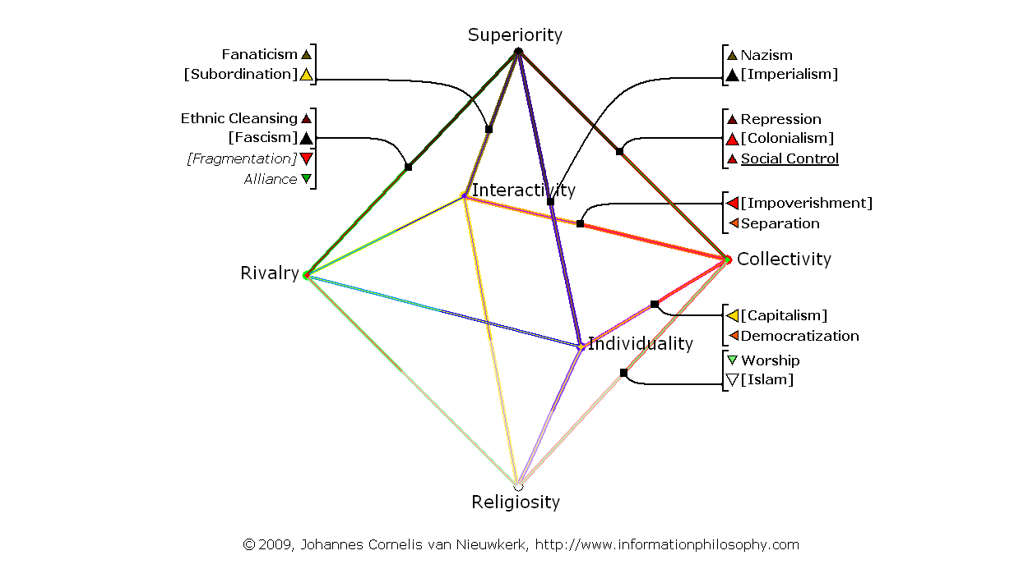

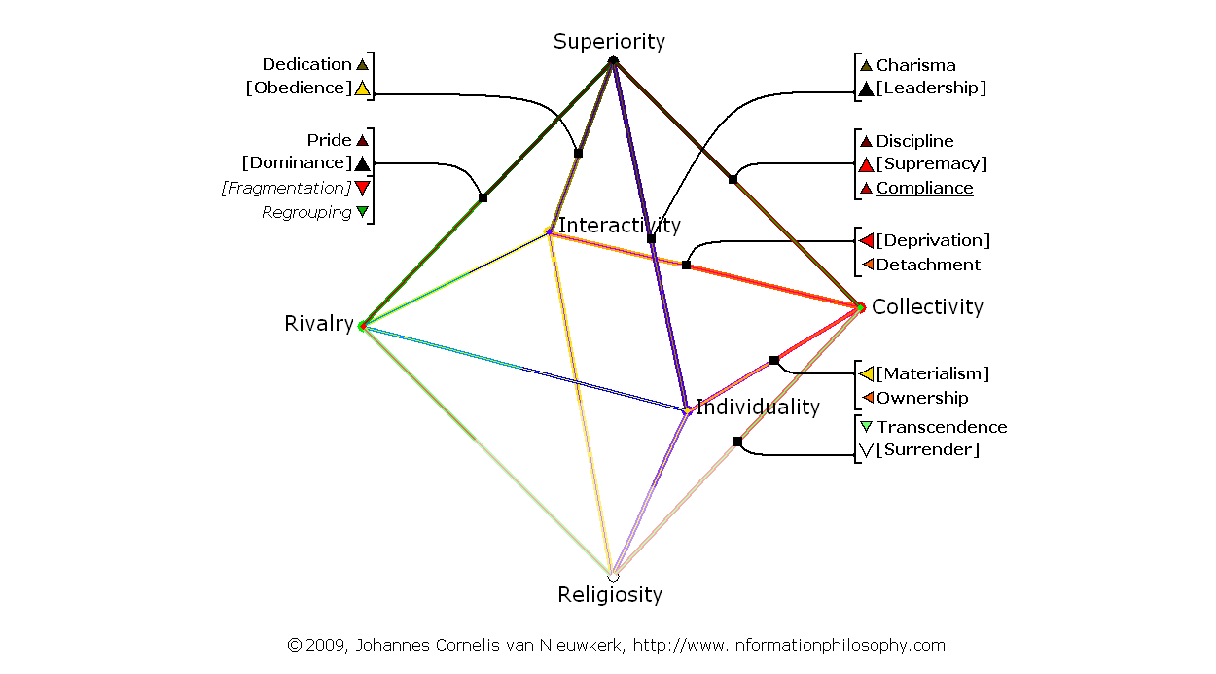
Map 6, Current Arab Leadership Culture, Dominant Forces, Personal View:

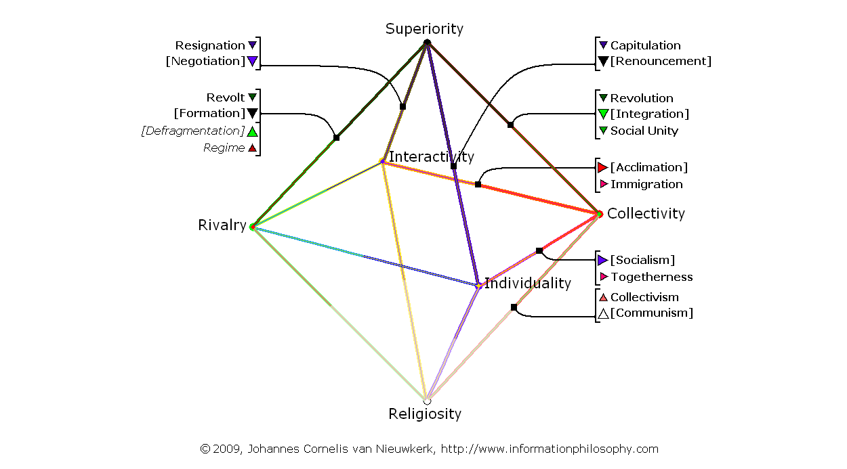
Map 7, Current Arab Leadership Culture, Counter Forces, Institutional View:

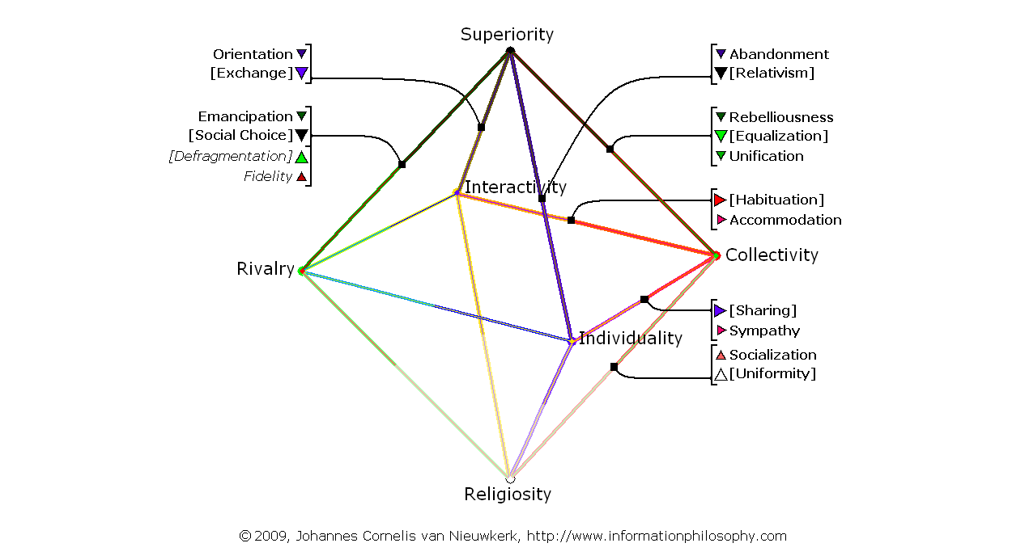
Map 8, Current Arab Leadership Culture, Counter Forces, Personal View:

Palestinian culture

Like the Arab culture, the Palestinian culture is primarily based on open association. It means that Arabs and Palestinians have Collectivity in common. Palestinians do not have a strong human leadership component as their second dimension however. Being impoverished and being deprived from having their physical country by “foreign” occupation and confiscation of land for a long period of time, the secondary (internal) relationship with Interactivity has become more important than the secondary relationship with leadership or Superiority as it can be found in Arab culture.

Interactivity is the attitude or cultural factor needed to “individually” survive and rationally communicate with other people in the same position when one becomes fully rationally dependent on each other in times of crisis and/or severe poverty. In case of the Palestinians it means forced cultural survival as economical refugees in other countries and by now in their own territories, which are still far from a save haven and where economic conditions remain deprived.

Although the “expression level” varies a lot between different interest representing organizations, the primary cohesive component of Palestinian culture is to be found in their resistant reaction on (forced and therefore adaptive) separation or detachment of Collectivity. It means that they have become dissidents of Collectivity focusing on protesting their political deprivation and impoverishment rather than to (in situations where this is possible) attempt to reconnect with or reestablish Collectivity.

The second non-dominant internal component in relation with Interactivity is economic displacement and/or political expulsion. However as long as the Palestinians are still able to strongly (emotionally) protest, this component is unlikely to be dominant. As stated before there does not seem to be a substantial reconnection tendency, this means that the cultural direction remains pointed towards Interactivity; Palestinians remain being forced away from emotionality and politically deprived. It implies that the external relationships of Palestinian culture are based on this.

In the external relations there remains a strong connection with their Arab cultural background. Both the external social control or compliance component in relation to (external) leadership or Superiority, and the Islamic worship or transcendence component in relation to Religiosity links the Palestinians up with neighboring Arab (mainstream and non-mainstream) cultures.

The third dominant side linked external component is the relationship with Individuality. Personal property and materialism are accepted; there also is a tendency towards democratization of rights of individuals. The issue of the positioning of individuals in relation to the group is important here, where on one side people are forcedly separated or detached and deprived, they at the same time get the theoretical space for personal materialistic freedom and democratization. Deprivation and general impoverishment do however strongly blur this effect.

On the (in this case only slightly) weaker Interactivity connected external relationship side entirely different, survival related, cultural components can be found. Although the (internal) origin of Palestinian deprivation is based on political disconnection, it has next to economical impoverishment also lead to loss of territory. This component is an external cultural relationship between Religiosity (representing spiritual unity or oneness here) and Interactivity. It follows the principle that physically weaker elements are from an ecological perspective being captured or controlled by the stronger ones. For the weaker elements this is a process of adaptation, they are forced doing so by the stronger ones. In human terms it means that people in a weaker position end up in serfdom or in servility to the stronger landowning or territory controlling parties. For Palestinians the previous meant that because of disconnection to Collectivity, external forces were able to take over their land. Although they captured them as a culture, they hardly took responsibility for the people living in the territory, which from an economic perspective again lead to further expulsion.

A revolutionary theoretical alternative could have been that the Palestinian people would have split, dissolved their collective cultural identity, and would have connected as individuals or as a servicing (economic) meso level minority to a conglomerate of other (non-collective) rivaling cultural identities. However this revolutionary scenario of affiliation or adapting to external cultural acceptance has not taken place and instead Palestinians have stayed together in solitude by the opposite direction process being (assertive, self-determined) dissociation from any other cultural identity. This dissociation or solitude process is based on the second (weaker side connected) external cultural component, the dissociation relationship between Interactivity and Rivalry.

The third non-dominant side connected external component is trade or reciprocity. It is related to a shift in the importance of leadership. Whereas in the mainstream Arab culture, leadership is an important (even internal) factor; it becomes less important when people become displaced or expulsed. Individual survival starts to become more dependent on the ability to negotiate or trade and to obtain necessities by reciprocal exchange with more powerful elements than on following leadership. Another reason is that if leadership (Superiority) on one side separates and expulses people, it can hardly at the same time (adaptively) expect subordination or obedience from them at the other. Negotiation and exchange, being (assertive) self-determined components, are a dominant and more logical attitude here.

Finally, as discussed before, the revolutionary component of affiliation or adapting to external cultural acceptance does not play any major role here. Because of separation or detachment, the “natural” emotional unity is disturbed by the Interactivity related increased need for individual survival. Separation however also blocks the way back, which could be re-immigration or accommodation. Being forced away, this is however no realistic option. There instead rises a tension for individuals (on a micro level) that are being split from Collectivity to try to affiliate with other fragmented (rivaling) groups. On a macro or meso level there also is the same tension for the entire separated segment to affiliate with Emotional Identity; at this level a conglomerate of fragmented groups. In case of being accepted as affiliates, the individuals or the segment can become member of a fragmented group or conglomerate and emotionally replace their Collectivity by membership this way.

To summarize: The Palestinian culture is dominantly collective with an impoverishment or political deprivation based interactivity component secondary linked to this Collectivity; the culture is traveling away from Collectivity towards Interactivity (EU=>IU). This means that the internal components are separation/detachment and expulsion/displacement. To the dominant side connected external relationships are social control/ compliance (SI), worship/transcendence (SU) and democratization/ ownership (II). To the in this case only slightly weaker side connected external relationships are solitude/dissociation (EI), trade/reciprocity (SI) and finally serfdom/servility (SU). The revolutionary component (EU=>EI) is fragmentation based and looks for affiliation/acceptance.

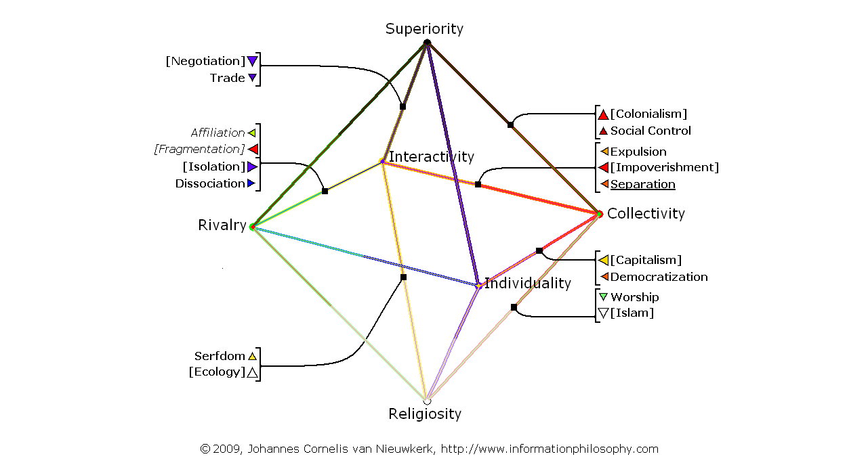
Map 9, Current Palestinian Culture, Dominant Forces, Institutional View:

Map 10, Current Palestinian Culture, Dominant Forces, Personal View:
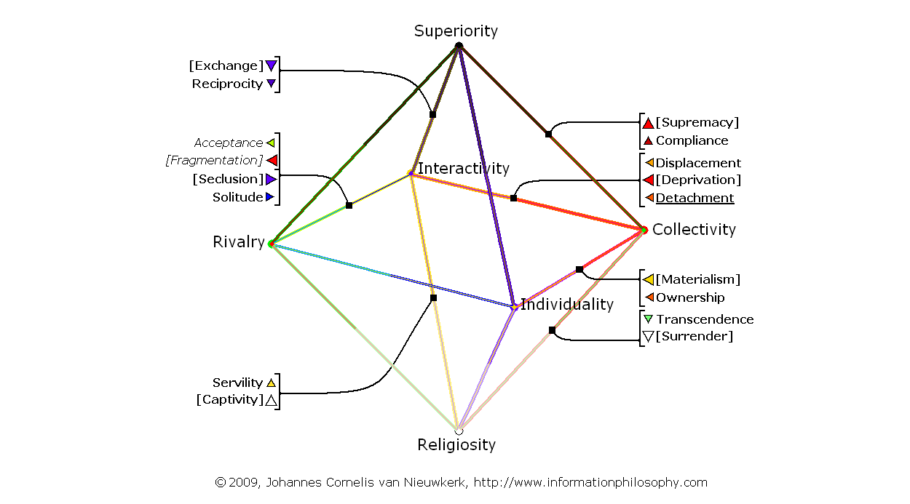

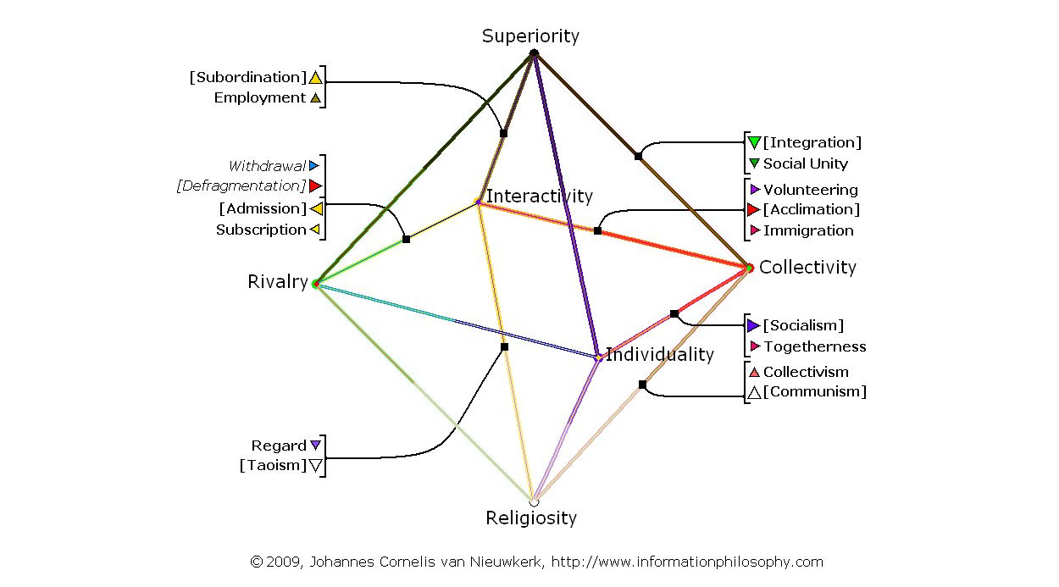
Map 11, Current Palestinian Culture, Counter Forces, Institutional View:

Map 12, Current Palestinian Culture, Counter Forces, Personal View:
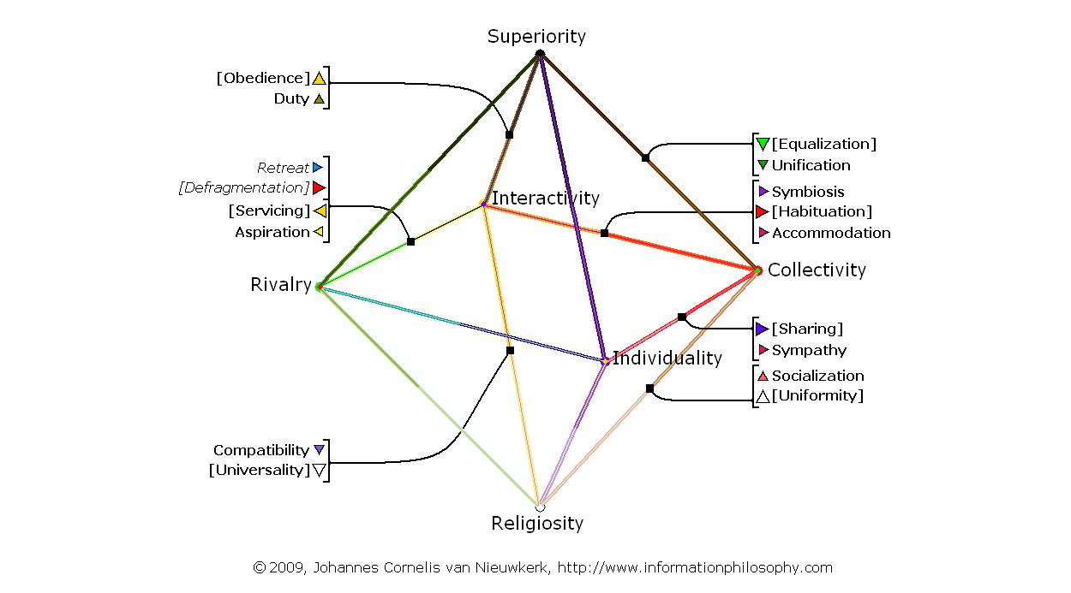

Israeli culture

Israeli culture has gone through a lot of transitions and is very dynamic; changing rapidly. In the beginning of the Zionist movement it has been a dominantly collective culture and has seen strong Eastern European socialist or communist influences. With immigration of great numbers of people with different cultural backgrounds, the Israeli culture became (revolutionary) fragmented but remained based on emotional association. This association was however now restricted and therefore rivalry based. Meanwhile the Israeli culture has become Individuality based and from a mainstream point of view, the independent position of the individual outweighs the association with the group. Not everyone changes with the same speed however; it means that in Israel a number of cultural models interact with each other and that a number of important subcultures can be found. Still there seems to be a common factor from an Information Philosophy point of view. Although dominance and direction do vary, the mainstream Israeli culture and most of its subcultures use the same two basic cultural communication elements, being Emotional Identity (Rivalry) and Rational Identity (Individuality). Neither Superiority nor Religiosity has ever been a dominant factor. Collectivity has been important in the beginning. But upon immigration of large number of people, which did not share the same relatively homogeneous background of the pioneers, it became fragmented. This article only looks at the current mainstream (dominant) cultural situation and is therefore a strong simplification of the complex reality.

In today’s Israeli culture the dominant cultural element is Individuality, the dominant communication is based on rational argumentation between people that are having various cultural roots. Culturally seen this element is a melting pot mechanism, it (adaptively, there is no self-determined choice, individualization is the result of non-functioning group loyalty) replaces fundamental and formalized non-association by individual space and freedom. Communication remains restricted however, the approach is egocentric. The secondary internal cultural communication component is restricted association or Emotional Identity (Rivalry) which represents the influence of the non-homogeneous groups people belong to or are originating from. The main direction between the two components is an increase in Individuality; a moving away from Rivalry. There is individual criticism or opposition against group obligations and against the inequality which is generated by the exclusivity of the group membership. The external relationships of Israeli culture are based on this.

The first external relationship with the dominant Individuality side is the relationship with Spiritual Unity or Religiosity. It is the assertive, non-religious (moving away from SU), component of regulation or territory. Israel is building fences in order to protect itself from the “outside world or spiritual total”. It protects its individual interests by demarcation and militarism.
The second external relationship with Individuality is the relationship with Superiority or Spiritual Identity. It is an adaptive ethical component which represents relativism or renouncement of leadership and Superiority. It is an anti-authority component. On a macro level it for Israel represents the process of ignoring the world’s opinion and to follow one’s own ethical reference instead. On an “internal” personal micro level it however at the same time represents the process of relativism of Israel’s own invincibility. Whereas before the start of the individualization process this component was directed towards Spiritual Identity and represented erudite superiority, this component has now been reversed into introspection; the military component has become more defensive and territory or demarcation instead of “scientific confidence” based this way.

The third external relationship with Individuality is the relationship with Emotional Unity or Collectivity. It is an assertive liberalistic capitalist or greed oriented materialistic component. It means the acceptance of unlimited aggregation of wealth as a positive individual and national accomplishment. This component implies a great distance to general (non emotional identity based) Collectivity.

The first external relationship with the weaker Emotional Identity or Rivalry side is the relationship with Spiritual Identity or Superiority. It is an assertive fidelity or regime based component which can lead towards fascism or dominance of a single rivaling group. People show fidelity to their group identity and combine this with presumed leadership. In Israel this component has two faces. The first (macro) face is a nationalistic, rivalry based, emotional fidelity to Israeli identity in relation to perceived external identities. The second (meso) face is the fidelity to the identity of the own ethnic group within the Israeli society. With individuals being dissatisfied and moving away from their identity, the identity itself tries to position itself more clearly by showing strength. This last component is the counterpart of alliance building and makes it hard to politically unite the ethnic or social fractions and their leaders.

The second external relationship with Rivalry is an adaptive religious adherence or ascension component in relation to Religiosity or Spiritual Unity. It is the type of component which can be found in Hinduism in case the contribution or devoutness to a higher purpose or higher level ascends the interests of the contributing group or split identity. This component means that ethnic or social groups culturally contribute (adaptively) to the Israeli society as a whole. Other than with the previous nationalistic component which is assertive and very often aggressive (thus limiting communication between groups) this component is its opposite. Groups start to have an open contribution to the total. From a meso point of view this can take rivalry away; uniting people. On a macro level it represents “Tikkun Olam” the Israeli social and spiritual contribution to mending the world. Being adaptive, this component is in praxis relatively weak however.
The third and last external relationship with Rivalry is an assertive withdrawal or retreat component in relationship with Interactivity or Individual Unity. Whereas members of ethnical or social entities who are affiliated with each other as meso rivaling parts of a macro conglomerate can regulate their individual (meso as well as micro) distance by the balance between assertive loyalty and adaptive criticism, are non-affiliates or “outcasts” not in the position to balance their influence by criticizing the Emotional Identity. Their relationship with Emotional Identity is based on the balance between adaptive affiliation (“their request for membership or acceptance”) versus assertive disconnection from the Emotional Identity. Disconnection being dominant here means that people voluntarily retreat or withdraw themselves from the macro Emotional Identity conglomerate. On a micro and meso level it seems that Arabs and Palestinians living in Israel separate themselves from connection to Israeli identity this way. Their withdrawal is more complex however and the component mentioned represents only part of the story. In order to actually withdraw one first has to have been part of something, for many Arabs or Palestinians it is very questionable that this has ever been the case. In the past this component has been reversed and consisted of a dominance of adaptive affiliation at times; this has however never lead to any “equal” position for the Arab and Palestinian minorities within the Israeli conglomerate. It seems that preserving the independent Arab and Palestinian cultural components has always outweighed the chances for or option of affiliation.

Finally there is a revolutionary tension between Individuality and Interactivity in Israeli culture. Individualism and egocentrism disturb general open communication between individuals. Self-reliance and independence however also block the way back, which could lead to at least a partial association by clustering in rivaling emotional identities. Since this is from an assertive (conflicting) point of view no realistic scenario any longer, there instead is aspiration for subscription to another Emotional Identity by replacing Individual Identity for Individual Unity. (giving up or “loosing” individualistic characteristics for rational reciprocity) This adaptive component only becomes important in crisis situations, which can lead to strong cultural dynamics. Even in that case it will be relatively weak because it is based on the connection between two adaptive circumstantial processes.

To summarize: The Israeli culture is dominantly individualistic with a criticism or opposition based rivalry component secondary linked to this. The culture is traveling away from Rivalry towards Individuality (EI=>II). This means that the internal components are independence/self-reliance and criticism/opposition. To the dominant side connected external relationships are regulation/territory (SU), ethics/introspection (SI) and liberalism/greed (EU). To the weaker side connected external relationships are regime/fidelity (EI), adherence/ascension (SU) and finally withdrawal/ retreat (IU). The revolutionary component (II=>IU) is “loosing” based and adaptively looks for subscription/aspiration.
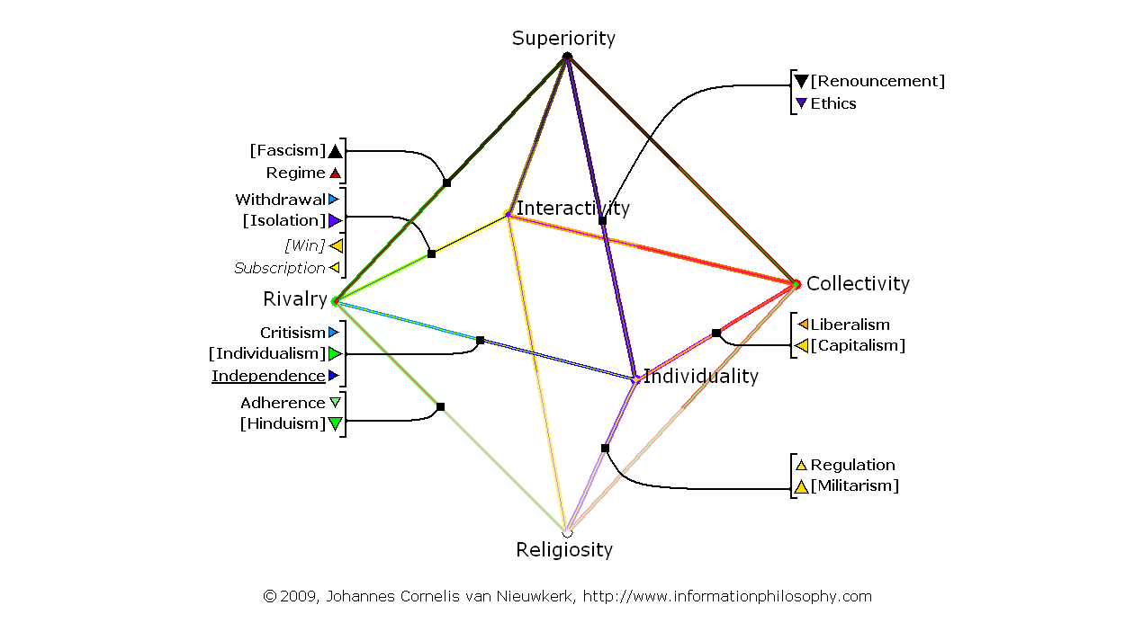
Map 13, Current Israeli Culture, Dominant Forces, Institutional View:

Map 14, Current Israeli Culture, Dominant Forces, Personal View:
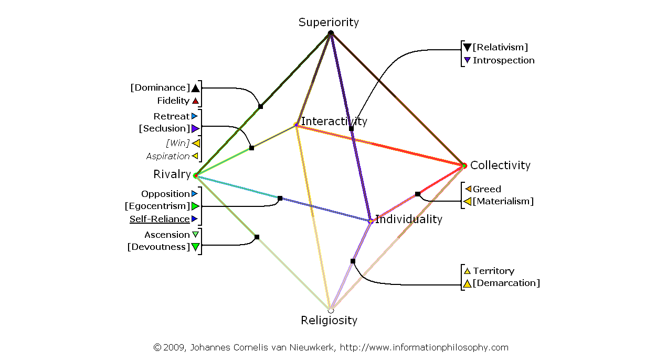

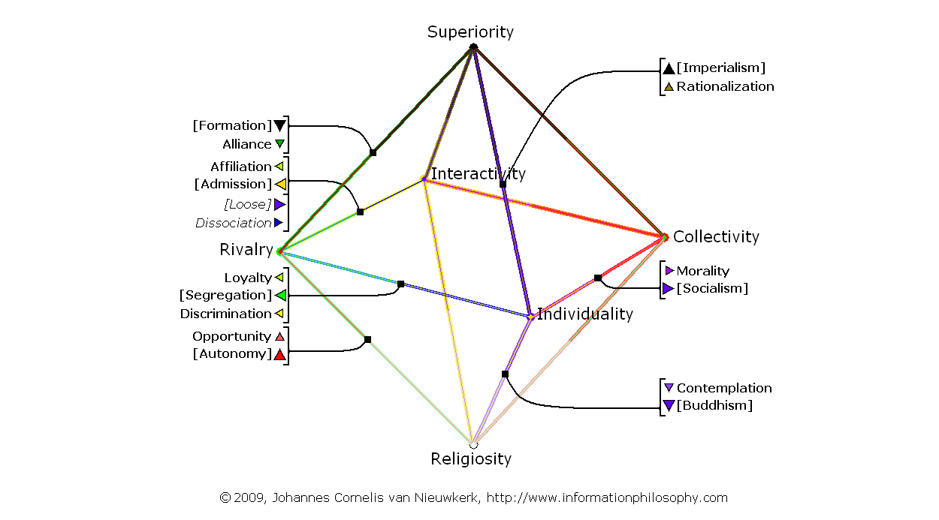
Map 15, Current Israeli Culture, Counter Forces, Institutional View:

Map 16, Current Israeli Culture, Counter Forces, Personal View:
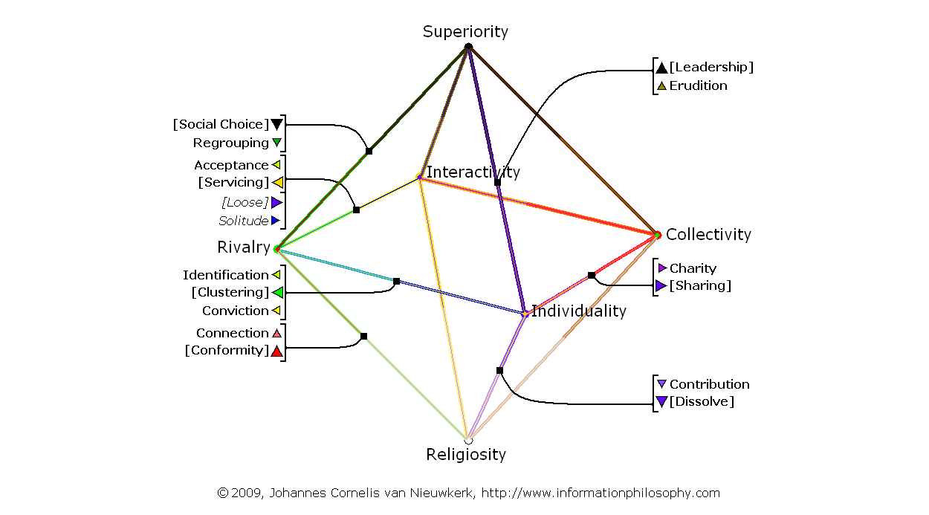

Communication between Arab, Palestinian and Israeli culture

In order to analyze the communication between the cultures the different maps have to be reviewed in respect to where they currently connect or do not connect. First the Arab and Palestinian maps will be compared, after that the Arab and Israeli maps will be compared and finally the Palestinian and Israeli maps will be compared.

Current Arab Palestinian Communication

Comparing the two maps shows that they have the primary collectivity element in common meaning that there is a high level of understanding between the two cultures. Although the secondary element is not the same, there also is similarity between them out of sharing social control/ compliance, worship/transcendence, democratization/ownership and finally separation/detachment as cultural components. What differs is their position.

Whereas the Arab culture has a strong power or Superiority/discipline related repression component, the Palestinian culture has an expulsion or displacement component instead. It means that their external connection in respect to the relation between Interactivity and Superiority conflicts with each other. Whereas the Arab culture expects the Palestinians to be subordinated, obedient and dedicated fans of them, the Palestinians (being separated and detached) do not see any reason for such behavior and expect a negotiation type of trade and exchange or even reciprocity instead. This is something the Arabs are not willing to offer.

It is the picture of the weaker and poorer Palestinians being “dissidents” of the Arab community. The result is a status quo. Although they very well understand each other’s point of view, they remain separated. The Arabs may defend the interests of the Palestinians in relation to external parties out of cultural similarity; this however does not mean much. Their cultural similarity implies to some extent that their interests likely also will have similarities and that defending them easily can be done out of self-interest.

Lacking a single cultural component which tries to assimilate or reintegrate the Palestinians into Arab culture means that as long as the Palestinians remain poor and deprived, they also will remain separated and detached and cannot expect much help from the Arab community in this respect.

Map 17, Current Arab Leadership Culture, Dominant Forces, Institutional View:

Map 18, Current Palestinian Culture, Dominant Forces, Institutional View:

Map 19, Current Arab Leadership Culture, Dominant Forces, Personal View:

Map 20, Current Palestinian Culture, Dominant Forces, Personal View:

Current Arab Israeli Communication

Comparing the two maps one can see that the two cultures have very little in common, they neither share any internal components nor do they have any external components in common. Israel is culturally not connected to its environment and actually has likely moved further away from it over time. In the early days of the Zionist pioneers it shared Collectivity with its neighbors. However also at that time their interpretation was likely opposite. Whereas the Zionist pioneers had a socialist or communist interpretation, their Arab neighbors followed the opposite direction.

Still there are four points where components of the two cultures touch.

The first touching point is the relationship between Collectivity and Individuality. Whereas the Israeli culture (externally) interprets Capitalism and Materialism as liberalism and greed, the Arab culture much more modestly interprets it as democratization and ownership. There is some individual freedom within Arab culture but the interests of the group strongly prevail; this is not the case in the liberalistic and materialistic Israeli society where the position of the individual is much stronger, even dominant. Although relatively weak this connection still generates some limited economical understanding between the two cultures.

The second touching point is the relationship between Superiority and Individuality. Here the two meeting components have opposite directions however. Whereas Arab culture has respect for charismatic leadership and Nazism, Israeli culture meanwhile possesses a relativism related anti-authority, ethical introspection component. This component leads to misunderstanding between the two parties since Arab culture interprets this introspection as weakness. The result is a certain level of disrespect.

The third touching point is the relationship between Superiority and Rivalry. There is a fascism or dominance component touching here, but the cultures are far apart. Whereas the Israeli culture shows a limited demand for group fidelity as a compensation for ongoing individualization, the Arab expectation for understanding is founded on a pride (and in its extreme form ethnic cleansing) based dominance of a single fraction. For Arab culture this would make their Israeli counterpart more similar to their own leadership based approach. This would be easier to understand from them.

Finally their fourth touching point is a special revolutionary and one-sided component. The Arab culture touches via its fragmentation based alliance/ regrouping component with Emotional Identity. The Israeli position is the opposite here: regime/fidelity. So there will be no alliance established.

Having almost nothing in common Arab-Israeli cultural communication is on an extremely low level and where the cultures touch each other there is likely more misunderstanding than understanding to be expected.
Map 21, Current Arab Leadership Culture, Dominant Forces, Institutional View:

Map 22, Current Israeli Culture, Dominant Forces, Institutional View:

Map 23, Current Arab Leadership Culture, Dominant Forces, Personal View:

Map 24, Current Israeli Culture, Dominant Forces, Personal View:

Current Palestinian Israeli Communication

Comparing the two maps one can see that similar to Arab culture the two cultures have very little in common. They neither share any internal components nor do they have any external components in common.

Still at four points, components of the cultures touch each other.

The first touching point is the relationship between Collectivity and Individuality. Whereas the Israeli culture (externally) interprets Capitalism and Materialism as liberalism and greed, the Palestinian culture (similar to the Arab culture) much more modestly interprets it as democratization and ownership. There is some individual freedom within Palestinian culture but the interests of the group strongly prevail; this is not the case in the liberalistic and materialistic Israeli society where the position of the individual is dominant. Although relatively weak this connection still generates limited economical understanding between the two cultures.

The second touching point is the relationship between Interactivity and Rivalry. The Palestinian map shows dissociation and solitude here whereas the Israeli map shows retreat and withdrawal here. Although both sides have an isolation or seclusion tendency in common, their interpretation and position is far apart. For the Palestinians their dissociation represents a culture protecting force that makes them stay together as “a community of expulsed individuals” and which blocks a possible tendency for aspiration or subscription (as servicing individuals or a servicing minority) to another cultural identity. For Israeli culture the force represents an unwillingness to accept any new “deprived or servicing” members. The communication result is a certain level of (negative) understanding. Both sides agree that they want to remain isolated from each other. The voluntary seclusion of the Palestinians fits to Israeli cultural tendencies.

The third touching point is a special revolutionary and one-sided one. The Palestinian map connects via its fragmentation based affiliation component with Emotional Identity. This revolutionary force differs (is opposite) from the previously discussed second touching point. Instead of isolation and seclusion there is attraction to affiliate and request for membership here. Israeli culture, showing a retreat and withdrawal component at this spot, does however not accept the request for affiliation. There is no connection.

Finally their fourth touching point is also a revolutionary and one-sided component. The Israeli culture touches via its “loosing” based subscription/ aspiration component with Individual Unity. But the Palestinian position is the opposite: dissociation/solitude. Also here there is no connection found.

Palestinian-Israeli communication is besides of some limited materialistic understanding and the current agreement from both sides to remain isolated, virtually non-existing. The two cultures are extremely far apart.
Map 25, Current Palestinian Culture, Dominant Forces, Institutional View:

Map 26, Current Israeli Culture, Dominant Forces, Institutional View:

Map 27, Current Palestinian Culture, Dominant Forces, Personal View:

Map 28, Current Israeli Culture, Dominant Forces, Personal View:

Potential future communication improvement scenarios

Having analyzed the current position of the three cultures and their momentary relationship, the next question is whether there are any theoretical options for future improvement imaginable.

Information Philosophy offers in principle theoretical itineraries from any cultural starting point to any cultural destination. Using this as a basis would however make the targets extremely far reaching and unrealistic. Therefore those scenarios have been selected that “just” require one single step of cultural change or migration. These steps can however be made by one or by both communicating parties. A further limitation is that options based on revolutionary components are ignored; these scenarios are also unlikely to become reality. A final more fundamental limitation is that only practical two-dimensional options will be discussed. Three-dimensional (mapping system changing) solutions are beyond the scope of this article.

Cultural change and migration, four scenarios

Before discussing the scenarios first the terms cultural change and cultural migration have to be defined. Information Philosophy defines cultural change as a change of the basic culture on the basis of a shift in balance between its internal components. It defines cultural migration as a change in culture based on replacement of one or two of its connecting poles.

There are two scenarios for cultural change and two scenarios for cultural migration; all four will now be briefly discussed into more detail.

The first scenario of cultural change is a change of dominance between the two connected poles. In case of Arab culture it could be a change from social control/compliance based culture to repression/discipline culture.

The second scenario of cultural change is a change of direction between the two connected poles. In case of the Arab culture example it could mean replacing social control/compliance by social unity/unification.

The first scenario of migration is a gradual change caused by the fact that an external force outweighs the internal force it connects to. If in Arab culture for example worship/transcendence outweighs social control/ compliance; the culture migrates. Religiosity replaces Superiority here and worship/transcendence and transparency/faith become the new internal processes. Social control/compliance is becoming an external factor now.

The second and last scenario of cultural migration is a revolutionary change of polarity of the dominant horizon. For Arab culture it would mean a change from Collectivity to Rivalry. The social control/compliance based culture would suddenly change into an alliance/regrouping culture.
Excluding revolutionary and multi-step cultural change/migration scenarios

Within the framework of excluding revolutionary and multi-step scenarios, the first scenario of cultural change and the second scenario of migration do not add any new perspective to the previously discussed current cultural communication relationships between the cultures. Whereas excluding the revolutionary migration is obvious, excluding the change of dominance between the two connected poles might be less clear and need some further explanation. This type of cultural change only changes the weight of the external forces but not the forces themselves. It means that besides of an exchange of the (excluded) revolutionary component no new point of view is added to the previously analyzed current communication.

The decision to only analyze one step scenarios and exclude revolutionary components implies the risk that possibly better more abrupt or multiple step scenarios are not taken into account. Within the restricted scope of the article this is a major limitation. Being illustrative rather than conclusive the following “improvement scenarios” have therefore to be interpreted with great care. Although their probability to occur might be higher, they may not offer the best outcome from a long term perspective.

This means that for the rest of this article only -1- the effects of changing the direction (internal balance) of the three cultures and -2- the possible scenarios for cultural migration on the basis of an increased importance of an external component; will be analyzed.

On the basis of the above there remain 75 (including the existing) potential future cultural communication combinations to be analyzed for the three cultures. Since cultural relations are viewpoint dependent and often asymmetrical, the actual number of balances between cultures to be analyzed is 150. First however clear classification criteria for the distance between cultures are needed in order to be able to make any comparisons.

Cultural communication distance classification, a mapping based approach

In order to classify the communication quality between cultures it is assumed that this relates to the strongest component they are sharing. The strength or distance of common components is therefore categorized.

For this article an objective mapping based distance system is used, although this generates a good estimation, factors like the subjective comparative strength of cultures (a strong or large size culture will have a different impact compared with a weak or small size one), the absolute position on the map (effects of change or migration vary at different positions on the map) and historical origin (a long tradition needs more time to be changed in a stable way) are excluded. Further research is needed; the classification has therefore to be interpreted with great care.
Cultural distance from close to remote, highest shared/common factor:

-10- Dominant internal component directed towards the dominant pole
-09- Dominant internal component directed away from the dominant pole
-08- Non-dominant internal component directed towards the dominant pole
-07- Non-dominant internal component directed away from the dominant pole
-06- Connected external component directed towards a dominant pole
-05- Connected external component directed away from a dominant pole
-04- Connected external component directed towards a non-dominant pole
-03- Connected external component directed away from a non-dominant pole
-02- Two shared poles but no sharing of internal components (opposite direction)
-01- Indirectly connected external component(s) (Two poles externally in line)
-00- Opposite direction between all external component(s) (No poles in line)

The first four (close) relationships are based on common internal components. In this case shared connections directed towards the dominant pole do create more synergy than connections directed away from the dominant pole. Poles possess certain magnetism and moving towards them is therefore mostly clearer than moving away from them.

The fifth until the eighth scenario (06-03) represent (medium distance) relationships between cultures that share only one of their two poles and which are this way connected by external instead of internal relationships. However if the two cultures possess an opposite direction in relation to their shared pole there will be no common (direct) external relationship.

The ninth (remote) scenario (02) represents two cultures which are identical in their information processing but travel in the opposite direction. Communication can be extremely difficult in this case because the cultures fundamentally clash. Their balancing counter forces keep the cultural communication open however. Mostly this process is a temporary process between opposite fractions within a culture; in that case it either represents a generation conflict or is the result of sudden political change.

The tenth (remote) scenario (01) represents relationships between cultures who either share a pole with an opposite external relationship or no poles at all. Between two non shared poles there can be an indirect relationship in case the two connecting processes are pointing into the same direction. The current Arab and Israeli culture, as discussed before, connect this way.

The eleventh (most remote) scenario (00) represents cultures who do not share any component with an equal direction between their poles. If the Palestinian or Israeli culture would change direction this would be the case.

The above classification makes it possible to evaluate how well cultures fit to each other. This however does not imply that communication is harmonious or assertive and that improvements will result in greater harmony or control. This topic will be discussed into more detail now.
Other Cultural Factors: Harmony or Disharmony, Assertive or Adaptive

Improving the closeness of the cultural distance does not necessarily guarantee any increase in total cultural harmony. It is easily possible to improve the connection between two “evil brothers”.

Although increasing communication closeness can often change the way in which frustration and violence is externally directed, it can not take the internal cultural sources of violence away. This can only be accomplished by using harmonious processes and by traveling towards more harmonious spots on the map.

In Information Philosophy a harmony hierarchy can be found between the connecting poles. Defined to be the most harmonious pole is Religiosity followed by Collectivity, Interactivity, Individuality, Rivalry and finally Superiority, which has been defined to be the most disharmonious pole. The more disharmonious the position of a culture is, the more likely it is that the culture will contain a high level of human identity related friction, which can lead to violence. This violence can either be directed internally, towards subcultures or individual members, or point at external cultures.

For a more extensive explanation of the harmony disharmony background an article named: Information Philosophy, Introduction, Mapping Cultural Communication can be downloaded from www.informationphilosophy.com.

An even more important factor is the direction of a culture, if a culture becomes more disharmonious, meaning that it travels towards a more disharmonic pole it will need more space and more likely will release its internal violence, whereas on traveling towards a more harmonious pole it will need less space and therefore also faces less need to release violence. For the analysis of the communication between the Arab, Palestinian and Israeli culture, it is therefore important to (next to the closeness) look at the direction of the total cultural development and it is also important to look at the nature of the cultural component the cultures share. If the shared cultural component is harmonic this will usually lead to harmonic understanding. If the shared component is disharmonic this will normally lead to disharmonic understanding.

Finally another aspect is whether the shared component between cultures has an assertive or adaptive nature. If it is assertive this creates greater control to influence it, which can be an important factor for realization. Assertive components can be relatively easily influenced by marketing their destination, whereas the success of adaptive components depends on public relations of the necessity to adapt to the friction at their source. Therefore it is easier to “sell” capitalism than socialism. Whereas capitalism creates the illusion of accessible wealth has socialism to rely on public relation based communication of the need to share individual wealth with others without any guarantee but the expectation of abstract togetherness.
Harmony and Religiosity, the positioning of Information Philosophy

Although Information Philosophy chooses/defines traveling towards (an oneness seeking type of) religiosity to be positive and harmonious; atheists, communists and many scientists will strongly disagree with this. In their opinion a “better”, “valid” and “harmonious” alternative can be found in human superiority based control. Non-religious people often view religion to represent human underdevelopment and therefore consider it to be “disharmonious” from their point of view.

The main difference between the two approaches is that the religious approach seeks for a balance with nature without reigning it. Humans are here an integral part of the universe and are not entitled to control nature by self supposed superiority. Religiosity assumes the omnipresence of a higher level force to whom humans are subordinated. This also implies the acceptance of death or nature based violence/selection as the “will of god”. The opposite, human control or Superiority based approach, optimizes the human position in the universe by reigning nature beyond balance. This vision allows mankind to disproportionally allocate space for its human expansion. Superiority also contradicts with voluntarily accepting death and therefore adherents to Superiority try to prolong life by scientifically controlling it. Finally the Superiority concept generates or accepts (as an ultimate consequence) absolute human leaders who can decide over life and death by repression, ethnic cleansing or conquering other’s territories.

Although Information Philosophy follows a Religiosity directed, Spiritual Unity based, approach for determining harmony it is aware of limitations. Worldly life is not paradise or heaven, and friction and adaptation towards friction have occurred over thousands of years. Traveling back to natural harmony is therefore rather a direction than a realizable practical concept. Still for cultural communication issues, avoidance of a further increase of disharmony or traveling towards harmony can reduce friction and violence.

For interpreting the results of the cultural comparisons in this article there is no difference between the two approaches. Both harmonious and disharmonious results will be discussed next to each other. The article shows all scenarios which improve communication, regardless whether these are harmonic or disharmonic. Often there is in the end a political choice to be made. Information Philosophy however stops at analyzing and proposing potential options. Political implementation is beyond its reach.

Within the scope of this article it is not possible to discuss all 75 scenarios or 150 balances in detail. Only those scenarios/balances will therefore be discussed which improve closeness between the three cultures involved. Two total diagrams on which all detailed cultural processes can be reviewed (allowing readers to analyze the balances themselves) and five comparative tables for the 150 balances are added as appendixes. Finally, resulting improvement scenarios can be discussed into more detail now.
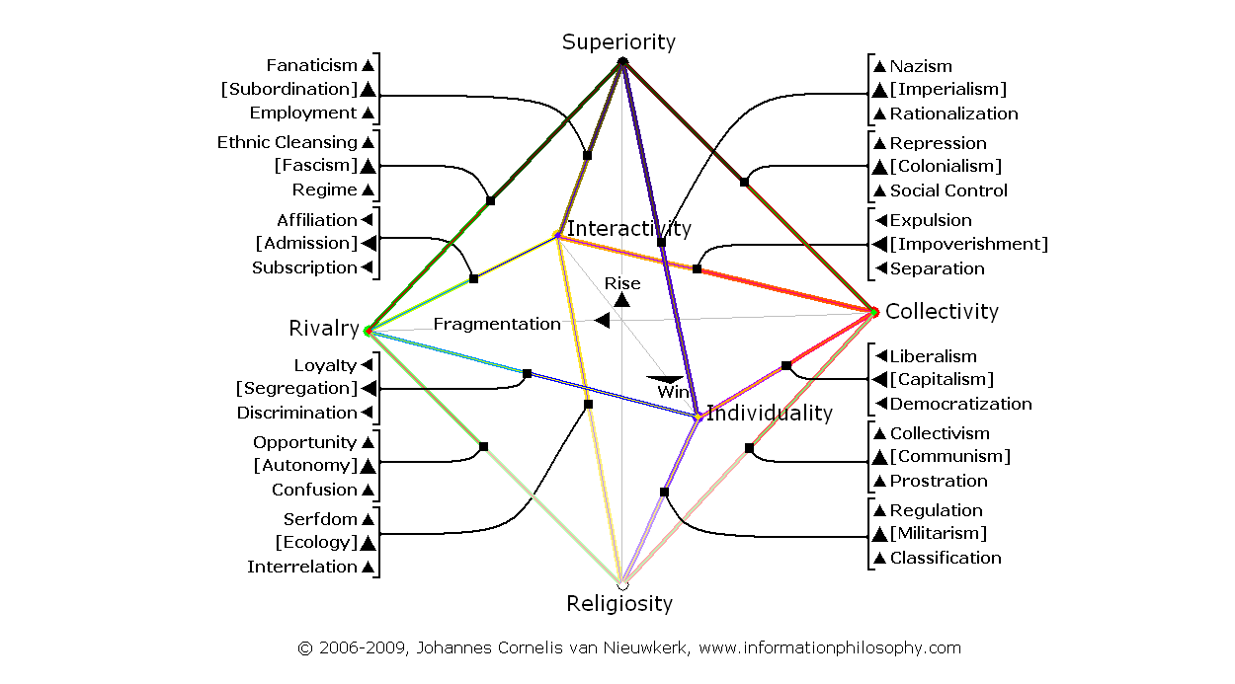
Map 29, Main and Detailed Disharmonious Processes, Institutional View:

Map 30, Main and Detailed Disharmonious Processes, Personal View:
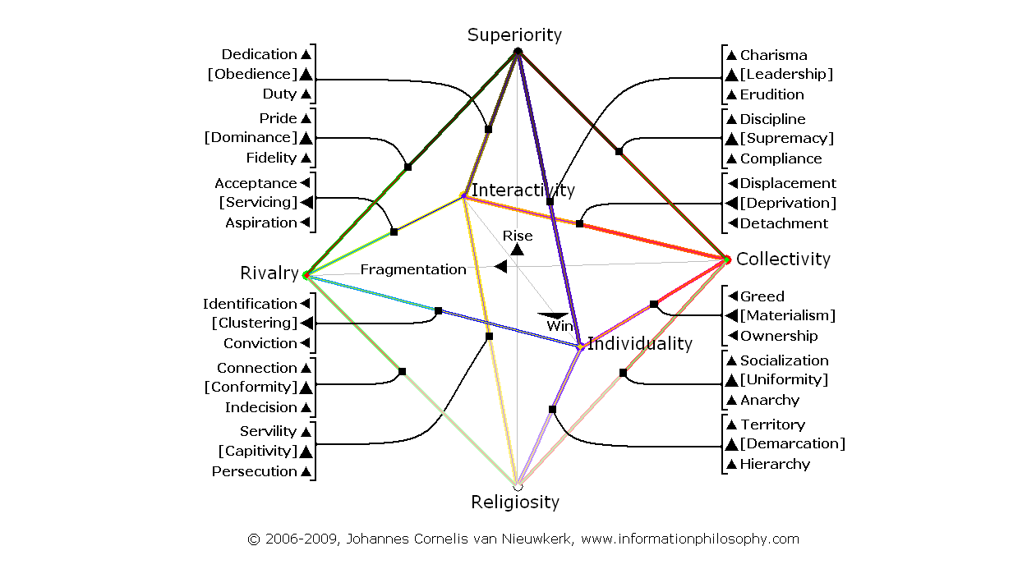

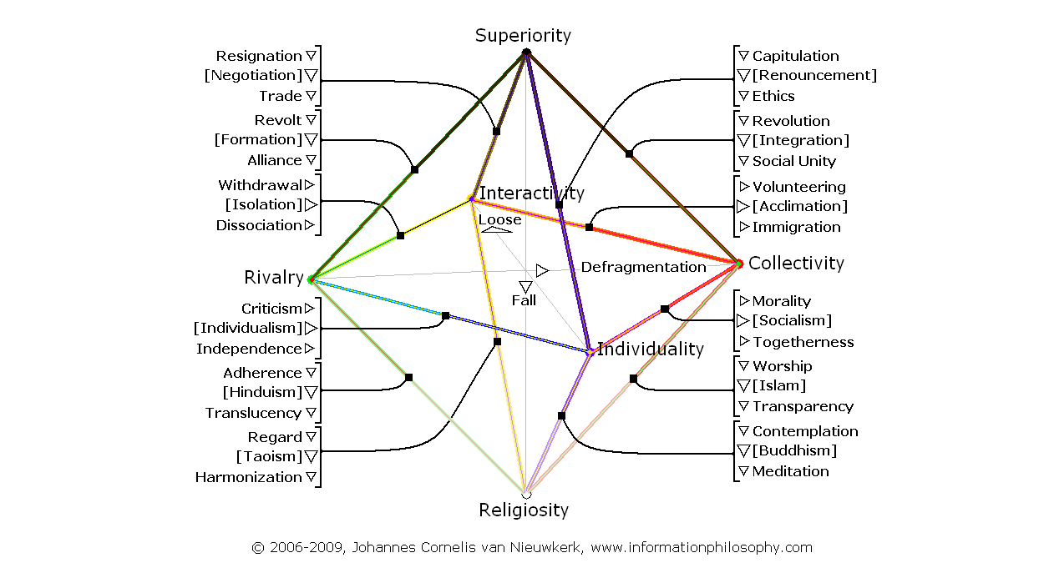
Map 31, Main and Detailed Harmonious Processes, Institutional View:

Map 32, Main and Detailed Harmonious Processes, Personal View:
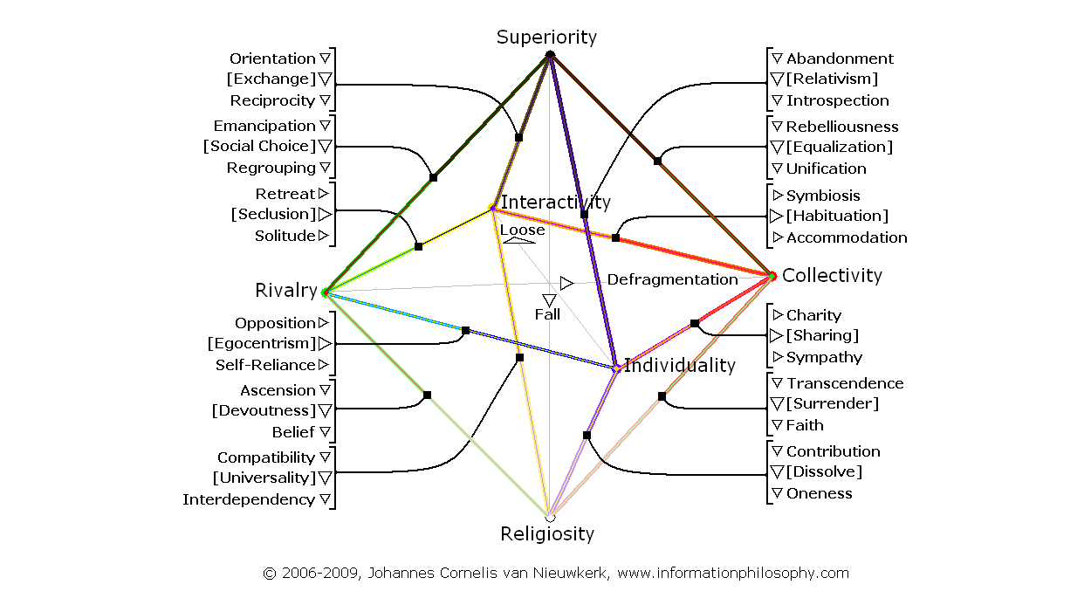

Improving Arab Palestinian Communication (see also: Tables 1-5)

Since the two cultures are relatively close to each other they can theoretically easily adapt by having their currently connecting external component outweighing an internal one. This means that Palestinians can become Arabs by simply making social control/compliance (migration) an internal instead of an external component. Practically seen it means that Palestinians can unite under strong leadership. This leadership will then be accepted both by their own people as well as by the “other” Arab leaders.

The second one-step/sided option is very unrealistic, namely that Arabs would become Palestinians and would become impoverished/deprived by separation/detachment.

Both one-step/sided migration options are adaptive and therefore difficult to control or influence. If strong Arab impoverishment would however occur or if a Palestinian leader would rise, there is a high likeliness that this would unite the two cultures.

All other improvement scenarios require a change from both cultures. There are three remaining scenarios here.

The Arab and Palestinian culture share two further external components being democratization/ownership and worship/transcendence. If both would internalize such a component they would become united by this. Practically spoken, it means that Arabs and Palestinians can opt for a Capitalist/Materialist or for an Islam/Surrender based cultural unification.

Capitalist/Materialist unification means replacing social control/compliance (Arab culture) and separation/detachment (Palestinian culture) for a common democratization/ownership component. Being assertive, it is a scenario which is relatively easy to market or sell to potential participants.

Islam/Surrender unification means replacing social control/compliance (Arab culture) and separation/detachment (Palestinian culture) for a common worship/transcendence component. Also being assertive it is a scenario which is relatively easy to market or sell to the people involved.

Finally, based on a mutual change of cultural direction, there is one weaker (non-unifying) improvement option left. In this scenario Arabs change from a social control/compliance based culture towards a social unity/unification based culture and Palestinians change from a separation/ detachment based culture towards an immigration/accommodation based culture. From an Arab point of view now immigration/accommodation becomes an external relation whereas from a Palestinian point of view social unity/unification becomes an external connection. This option assumes a strong cultural change; since both components are assertive it is theoretically possible to stimulate such a development however.

To summarize the five Arab-Palestinian communication improvement options:
-1- (1C/C1) 09 Social Control/Compliance (Strongest common comp.)
-2- (4A/A4) 09 Separation/Detachment
-3- (3D/D3) 09 Democratization/Ownership
-4- (5E/E5) 09 Worship/Transcendence
-5- (2B) 06 Immigration/Accommodation (Arab view)
(B2) 06 Social Unity/Unification (Palestinian view)
(No,No Table,Level,Results:Fat=Harmonic sharing;Underline=Assertive sharing;Italic=Disharm. total)

The question is which scenario is the most likely or wishful one. From an Information Philosophy harmony point of view, the fourth (Religious) scenario is the preferred one. It does however poorly fit to general “global” disharmonious developments. Because of social control/compliance being a relatively disharmonious component; the first scenario is the most disharmonious option and therefore unless no other options are available not a wishful one. The second and fifth scenarios are as explained before relatively unlikely scenarios. It means that the third (Capitalist) scenario, although disharmonious and not wishful, has the highest likeliness to bring the two cultures together. Being an assertive scenario it is also a scenario that can be relatively easily marketed or influenced.

Cultural Maps for all scenarios can be found as appendices to this article.

Improving Arab Israeli Communication (see also: Tables 1-5)

Since the two cultures are culturally extremely far apart there is no single step theoretical scenario thinkable that would fully integrate the two cultures. There are however a number of scenarios that can substantially improve the communication quality and understanding between them.

There are eight improvement scenarios; seven of them are single or double sided migration scenarios and related by the point they travel to. The last improvement scenario is a mixture between migration and change and differs fundamentally from the first seven.

The first seven scenarios have in common that one of the two (or both) cultures travels from the current starting points: social control/ compliance (Arab) and independence/self-reliance (Israeli) closer to the Capitalism/ Materialism axis. Regardless of in which direction the other culture migrates this will always improve the closeness between the two cultures. If the two cultures both travel towards Capitalism/Materialism they get as close as they can get. If only one of the cultures travels into the direction of Capitalism/Materialism and the other into another direction the common component and the resulting level or type of understanding can still vary. Without any culture traveling towards Capitalism/Materialism there is (with exception of the eighth scenario) no improvement possible.
In the eighth, mixed migration and change improvement scenario, the Arabs change from a social control/compliance based culture towards a social unity/unification based culture and the Israelis migrate from an independence/self-reliance based culture towards an ethics/introspection based culture. From an Arab point of view now capitulation/abandonment becomes an external relation whereas from an Israeli point of view revolution/rebelliousness becomes an external connection. In practice this means that they externally share their moving away from strong leadership/Superiority. More practically spoken there is understanding for an Arab (anti leadership) revolution from the Israeli side here. Since this option however assumes both adaptation on the Israeli and a strong cultural change on the Arab side, it in reality is not a very likely scenario.

Eight Arab-Israeli options to improve communication (main/common components):
-1- Arab: democratization/ownership, Israel: liberalism/greed
(8I) 07 liberalism/greed (Arab View) (2 sided migration)
(I8) 08 democratization/ownership (Israeli view) (2 sided migration)
-2- Arab: democratization/ownership, Israel: independence/self-reliance
(8F) 04 independence/self-reliance (Arab view) (1 sided migration)
(F8) 04 liberalism/greed (Israeli view) (no migration)
-3- Arab: social control/compliance, Israel: liberalism/greed
(6I) 03 democratization/ownership (Arab view) (no migration)
(I6) 03 social control/compliance (Israeli view) (1 sided migration)
-4- Arab: democratization/ownership, Israel: ethics/introspection
(8H) 04 ethics/introspection (Arab view) (2 sided migration)
(H8) 04 liberalism/greed (Israeli view) (2 sided migration)
-5- Arab: democratization/ownership, Israel: regulation/territory
(8J) 04 regulation/territory (Arab view) (2 sided migration)
(J8) 04 liberalism/greed (Israeli view) (2 sided migration)
-6- Arab: separation/detachment, Israel: liberalism/greed
(9I) 03 democratization/ownership (Arab view) (2 sided migration)
(I9) 03 separation/detachment (Israeli view) (2 sided migration)
-7- Arab: worship/transcendence, Israel: liberalism/greed
(10I) 03 democratization/ownership (Arab view) (2 sided migration)
(I10) 03 worship/transcendence (Israeli view) (2 sided migration)
-8- Arab: social unity/unification, Israel: ethics/introspection
(7H) 03 capitulation/abandonment (Arab View) (Change)
(H7) 03 revolution/rebelliousness (Israeli View) (Migration)
(No, No Table, Level, Results: Fat=Harmonic sharing; Underline=Assertive sharing)

Neither of the listed scenarios is fully integrating the two cultures nor are the scenarios symmetrical, this makes it more difficult to analyze them. Besides of the sixth and eighth scenario they are all feasible. The question remains which scenario is the most likely or wishful.

Eight Arab-Israeli options to improve communication (harmony levels):
-0- Arab: social control/compliance, Israel: independence/self-reliance
(6F) 01 total: 0 main: – shared: – (Arab culture/view)
(F6) 01 total: 0 main: + shared: – (Israeli culture/view)
-1- Arab: democratization/ownership, Israel: liberalism/greed
(8I) 07 total: + main: – shared: – (Arab culture/view)
(I8) 08 total: + main: – shared: – (Israeli culture/view)
-2- Arab: democratization/ownership, Israel: independence/self-reliance
(8F) 04 total: + main: – shared: + (Arab culture/view)
(F8) 04 total: 0 main: + shared: – (Israeli culture/view)
-3- Arab: social control/compliance, Israel: liberalism/greed
(6I) 03 total: 0 main: – shared: – (Arab culture/view)
(I6) 03 total: + main: – shared: – (Israeli culture/view)
-4- Arab: democratization/ownership, Israel: ethics/introspection
(8H) 04 total: + main: – shared: + (Arab culture/view)
(H8) 04 total: – main: + shared: – (Israeli culture/view)
-5- Arab: democratization/ownership, Israel: regulation/territory
(8J) 04 total: + main: – shared: – (Arab culture/view)
(J8) 04 total: + main: – shared: – (Israeli culture/view)
-6- Arab: separation/detachment, Israel: liberalism/greed
(9I) 03 total: + main: – shared: – (Arab culture/view)
(I9) 03 total: + main: – shared: – (Israeli culture/view)
-7- Arab: worship/transcendence, Israel: liberalism/greed
(10I) 03 total: + main: + shared: – (Arab culture/view)
(I10) 03 total: + main: – shared: + (Israeli culture/view)
-8- Arab: social unity/unification, Israel: ethics/introspection
(7H) 03 total: + main: + shared: + (Arab culture/view)
(H7) 03 total: – main: + shared: + (Israeli culture/view)
(No,No Table,Level,Total Dev.,Main Component,Shared Component,Harmony=+/–/0,Underline=Assert.)

The table above shows an overview of the harmony aspects of the eight scenarios. Next to reviewing the change of the position on the total map, it illustrates the harmonic or disharmonic nature of the main cultural component and of the component shared with the other culture (seen from the culture’s own perspective). Finally it shows adaptive/assertiveness.

Reviewing the table there is no single clear answer to the question which scenario is the most likely or wishful one. The alternatives will therefore be briefly discussed.

From a communication closeness point of view, the first (Arab: democratization/ownership, Israel: liberalism/greed) scenario is the preferred one. It is however a scenario built on two disharmonious main components, which implies that is not without friction. Practically spoken this scenario represents full “westernization” of the Arab world and together with this, a loss of Arab identity by materialistic individualization.
Although reaching a lower level of closeness, the second (Arab: democratization/ownership) based scenario is similar to the first. There is Arab “westernization” here but Israeli culture (remaining unchanged) does not get closer in respect to improving cultural communication in this case.

The third (Arab: social control/compliance, Israel: liberalism/greed) scenario neither offers much closeness nor does it offer any harmony of the main components. Compared with the first scenario it is inferior. Since the current Arab world would remain culturally untouched, it is a realistic business scenario however. From the side of Israel it presumes assertive liberalism/greed instead of current adaptive independence/self-reliance. Practically this means a change in attitude from “as long as my neighbor does not bother me it is ok” towards a Capitalistic (aggressive) “what is in it for me” type of trading/negotiation relationship with its Arab neighbors.

Also the fourth and fifth scenarios presume Arab “westernization”. The difference is the Israeli position. Although not improving communication much; the fourth scenario (Arab: democratization/ownership, Israel: ethics/introspection) can be a good alternative for the second scenario (Arab: democratization/ownership, Israel: independence/self-reliance). Ethics/introspection replaces independence/self-reliance. It means that “as long as my neighbor is not (emotionally) close and does not bother me; it is ok” is replaced by “as long as nobody tries to tell me how and when to do things I am free to think for myself; it is ok”; both components are adaptive however. The fifth (Arab: democratization/ownership, Israel: regulation/territory) scenario is a Militarism/Demarcation based scenario, which is clearly more disharmonious compared with the second and fourth scenarios. It should therefore be avoided. Arab “westernization” in combination with Israeli Demarcation does not optimize communication.

The sixth scenario (Arab: separation/detachment, Israel: liberalism/ greed) is currently unrealistic. Arabs would become impoverished/ deprived by separation/detachment in this scenario. It is further ignored.

The seventh (Arab: worship/transcendence, Israel: liberalism/greed) scenario means a cultural dominance for Islam/Surrender in the Arab world. It is a religious scenario. This option has however little to do with fundamentalist violent social control/compliance or sometimes even repression/discipline based Islam approaches. Such directions are often Superiority instead of Religiosity based and are much closer to a strong leadership oriented Arab cultural model as they are to a submission based religious one. Islam means a common and unified worship/transcendence based lifestyle here. If Arab wealth would be evenly shared with all inhabitants this vision could be a realistic option, otherwise it will likely lead to poverty out of a lack of structure. In a globalized disharmonic environment, the Arab world would not be able to compete from an economical point of view however. The Israeli position in this relatively harmonious option is a Capitalist/Materialist trading or negotiating one.
The eighth scenario of sharing the moving away from strong leadership/ Superiority assumes as previously discussed both adaptation on the Israeli and a strong cultural change on the Arab side; in reality it is therefore an unlikely scenario.

Comparing the six realistic scenarios they all have their plusses and minuses, but what is their likeliness? All three main Arab options: a status quo, Arab “westernization” or a stronger Islam are thinkable options. An Israeli cultural switch towards Capitalism/Materialism from Individualism/ Egocentrism is also well possible. Unfortunately none of the likely communication scenarios is very harmonious. The Capitalist/Materialist axis is what disharmoniously links the two cultures.

Cultural Maps for all scenarios can be found as appendices to this article.

Improving Palestinian Israeli Communication

Since the two cultures are very close to each other, the Palestinian scenarios are identical to the previously discussed Arab ones. There is one exception, namely that the eighth scenario is absent. Immigration/ accommodation does not generate such an option. The previous descriptions are also valid for Palestinian culture. Also here the Capitalist/ Materialist axis disharmoniously links Palestinian and Israeli culture.

Seven Palestinian-Israeli improvement options (main/common components):
-1- Palestinian: democratization/ownership, Israel: liberalism/greed
(14N) 07 liberalism/greed (Palestinian view) (2 sided migration)
(N14) 08 democratization/ownership (Israeli view) (2 sided migration)
-2- Palestinian: democratization/ownership, Israel: independence/self-reliance
(14K) 04 independence/self-reliance (Palestinian view) (1 sided m.)
(K14) 04 liberalism/greed (Israeli view) (no migration)
-3- Palestinian: separation/detachment, Israel: liberalism/greed
(11N) 03 democratization/ownership (Palestinian view) (no migr.)
(N11) 03 separation/detachment (Israeli view) (1 sided migration)
-4- Palestinian: democratization/ownership, Israel: ethics/introspection
(14M)04 ethics/introspection (Palestinian view) (2 sided migration)
(M14)04 liberalism/greed (Israeli view) (2 sided migration)
-5- Palestinian: democratization/ownership, Israel: regulation territory
(14O)04 regulation/territory (Palestinian view) (2 sided migration)
(O14)04 liberalism/greed (Israeli view) (2 sided migration)
-6- Palestinian: social control/compliance, Israel: liberalism/greed
(13N) 03 democratization/ownership (Palestinian view) (2 sided migration)
(N13) 03 social control/compliance (Israeli view) (2 sided migration)
-7- Palestinian: worship/transcendence, Israel: liberalism/greed
(15N) 03 democratization/ownership (Palestinian view) (2 sided migration)
(N15) 03 worship/transcendence (Israeli view) (2 sided migration)
(No, No Table, Level, Results: Fat=Harmonic sharing; Underline=Assertive sharing)

Seven Palestinian-Israeli communication improvement options (harmony levels):

-0- Palestinian: separation/detachment, Israel: independence/self-reliance
(K11) 01 total: 0 main: + shared: – (Israeli culture/view)
(11K) 01 total: 0 main: – shared: – (Palestinian culture/view)
-1- Palestinian: democratization/ownership, Israel: liberalism/greed
(14N) 07 total: + main: – shared: – (Palestinian culture/view)
(N14) 08 total: + main: – shared: – (Israeli culture/view)
-2- Palestinian: democratization/ownership, Israel: independence/self-reliance
(14K) 04 total: + main: – shared: + (Palestinian culture/view)
(K14) 04 total: 0 main: + shared: – (Israeli culture/view)
-3- Palestinian: separation/detachment, Israel: liberalism/greed
(11N) 03 total: 0 main: – shared: – (Palestinian culture/view)
(N11) 03 total: + main: – shared: – (Israeli culture/view)
-4- Palestinian: democratization/ownership, Israel: ethics/introspection
(14M)04 total: + main: – shared: + (Palestinian culture/view)
(M14)04 total: – main: + shared: – (Israeli culture/view)
-5- Palestinian: democratization/ownership, Israel: regulation territory
(14O)04 total: + main: – shared: – (Palestinian culture/view)
(O14)04 total: + main: – shared: – (Israeli culture/view)
-6- Palestinian: social control/compliance, Israel: liberalism/greed
(13N) 03 total: + main: – shared: – (Palestinian culture/view)
(N13) 03 total: + main: – shared: – (Israeli culture/view)
-7- Palestinian: worship/transcendence, Israel: liberalism/greed
(15N) 03 total: + main: + shared: – (Palestinian culture/view)
(N15) 03 total: + main: – shared: + (Israeli culture/view)
(No,No Table,Level,Total Dev.,Main Component,Shared Component,Harmony=+/–/0,Underline=Assert.)

Cultural Maps for all scenarios can be found as appendices to this article.

Summary and Conclusions

The research for this article has been very limited. Out of a lack of funds, almost no field research has been done and assumptions have been mainly made on the basis of very limited media exposure. This is of course a very risky and slippery approach with questionable value from a traditional science point of view; it however generates another perspective.

The result is a practical superficial comparison between countries; a momentary illustrative snapshot. From this snapshot dynamic theoretical scenarios for improvement can be derived however. Blueprints that can help people with detailed local knowledge to more properly analyze the cultural communication environment and its related options for improvement. The article itself remains an illustration of methodology; there is no target to come with conclusive or final results at this stage.

Three cultures have been used as an example; a cultural profile summary:

The Arab mainstream culture is dominantly collective with a leadership based spiritual component linked to this collectivity; it is traveling away from collectivity towards superiority. This means that its main components are social control/compliance and repression/discipline.

Also the Palestinian culture is dominantly collective with secondary linked an impoverishment or political deprivation based interactivity component; the culture is traveling away from collectivity towards interactivity. This means that its main components are separation/detachment and expulsion/displacement.

The Israeli culture is dominantly individualistic with a secondary linked criticism or opposition based rivalry component to it. The culture is traveling away from rivalry towards individuality. This means that the main components are independence/self-reliance and criticism/opposition.

Comparing the Arab and Palestinian cultures shows that they have their collectivity element in common. There is a high level of understanding. Although their secondary element is not the same, there is similarity between them out of sharing social control/compliance, worship/ transcendence, democratization/ownership and finally separation/ detachment as cultural components. What differs is their position. As long as the Palestinians remain poor and deprived; they will remain detached.

Comparing the Arab and Israeli cultures one can see that the two cultures have very little in common, they neither share any internal components nor do they have any external components in common. Having almost nothing in common Arab-Israeli cultural communication is at an extremely low level and where the cultures touch each other there is likely more misunderstanding than understanding to be expected.
Comparing the Palestinian and Israeli cultures one can see that similar to the Arab culture, the two cultures have very little in common. They neither share any internal components nor do they have any external components in common. Palestinian-Israeli communication is besides of some limited materialistic understanding and the current agreement from both sides to remain isolated, virtually non-existing.

Cultural communication improvement scenarios, a summary of options:

Since the Arab and Palestinian cultures are relatively close to each other they can theoretically easily adapt by having their currently connecting external component outweighing an internal one. This means that Palestinians can become Arabs by simply making social control/compliance (migration) an internal instead of an external component. Practically seen it means that Palestinians can unite under strong leadership. This leadership will then be accepted both by their own people as well as by the “other” Arab leaders. Alternatively an Islam based Religious unification can be accomplished. This scenario does however poorly fit to general “global” disharmonious developments. Finally there is a third scenario that has the highest realistic likeliness to bring the two cultures together. This option is based on shared democratization/ownership; it is a Capitalist/Materialistic scenario.

In respect to improving the Arab/Palestinian Israeli relationship all three main Arab/Palestinian options being a status quo, Arab/Palestinian “westernization” or a stronger Islam are thinkable and can be part of improved closeness. An Israeli cultural migration towards capitalism/ materialism from individualism/egocentrism is also well possible and can contribute to bridging the gap. Unfortunately none of the resulting communication scenarios is very harmonious.

Finally a short outlook: how to long term bring the three cultures together?

Arab and Palestinian culture are relatively close and are therefore easy to integrate with many options to do so; this whereas Israeli culture is far away and currently has only limited options to connect with.

It is therefore likely a good idea to first (re)integrate Arab and Palestinian culture, not in the last place because part of the Palestinian friction is related to their relationship with Arab culture. Violence is directed towards Israel but its origin is partly found in detachment from Arab culture; not from Israeli culture.

Directing violence against a poorly communicating neighbor is of course always easy. A long chain of misunderstood violent actions/reaction easily escalates when no real communication channels are available between parties.

The second step is more difficult: how to get Arab/Palestinian and Israeli culture closer? Although this article indicates that the Capitalist/Materialist axis offers solutions, much further research has to be done in this area.

Getting closer on the Capitalist/Materialist axis means stimulating business, creating conditions whereby there is something to be gained for everybody.

The problem with this axis is that it is not very harmonious and also that it assumes the Arab world to “westernize” which could mean a loss of Arab Religious identity and a loss of the current collective cultural lifestyle.

Although the article has shown some Religion based alternatives it has not been possible to (within the scope of the article) analyze two-step or three-dimensional scenarios.

Probably this is however needed to develop more harmonious longer term alternative scenarios. Substantial further research has to be done in this area.

Advanced scenarios can likely bring more dynamics to the Israeli side as well. This side is currently very static from a cultural point of view. If it would for example be possible to add a Religious or Collective component to Israeli culture, this could substantially enrich the cultural spectrum.

Hopefully additional enriching scenarios can be found. Scenarios which could establish durable long term harmonious solutions for the Middle East.

© 2009, Johannes Cornelis van Nieuwkerk
Budapest, 29 January 2009

Johannes Cornelis van Nieuwkerk
P.O. Box 275, 3000 AG Rotterdam
The Netherlands
GSM: +423 663 019 190/+36 20 9877082
Email: jcn@informationphilosophy.com
Appendices
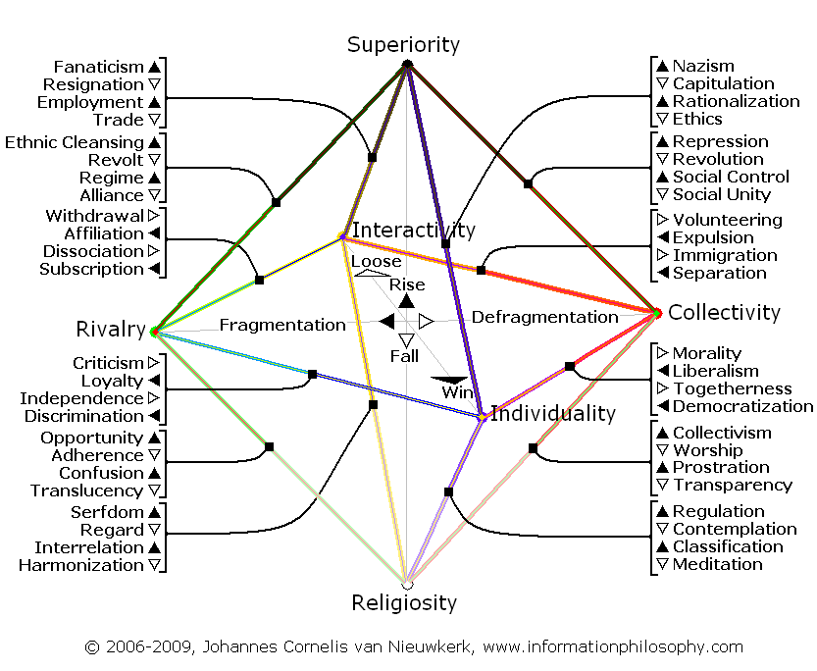
Map 33, Harmony/Disharmony (W/B), All Detailed Processes, Institutional View:

Map 34, Harmony/Disharmony (W/B), All Detailed Processes, Personal View:
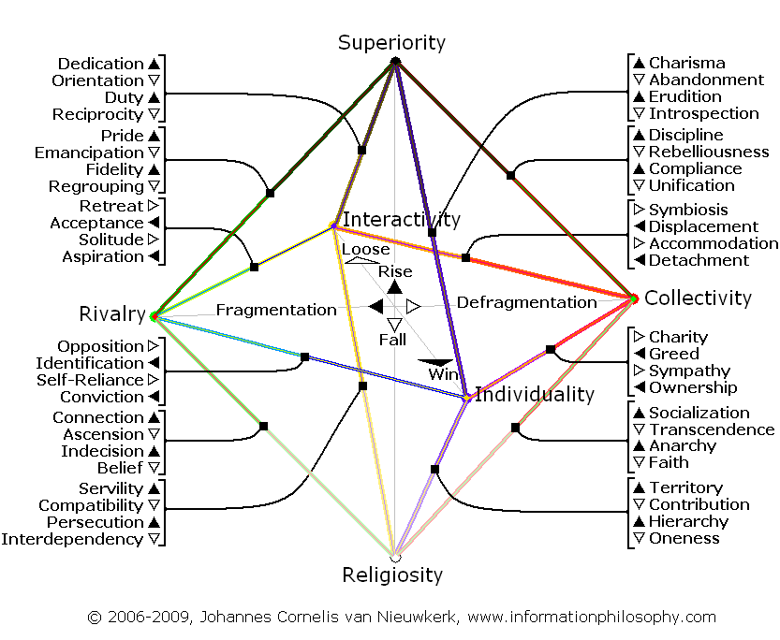

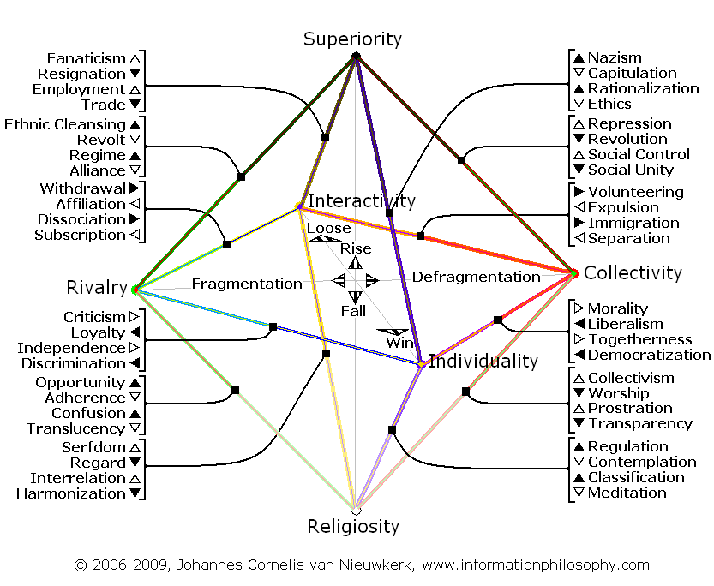
Map 35, Adaptive/Assertive (W/B), All Detailed Processes, Institutional View:

Map 36, Adaptive/Assertive (W/B), All Detailed Processes, Personal View:
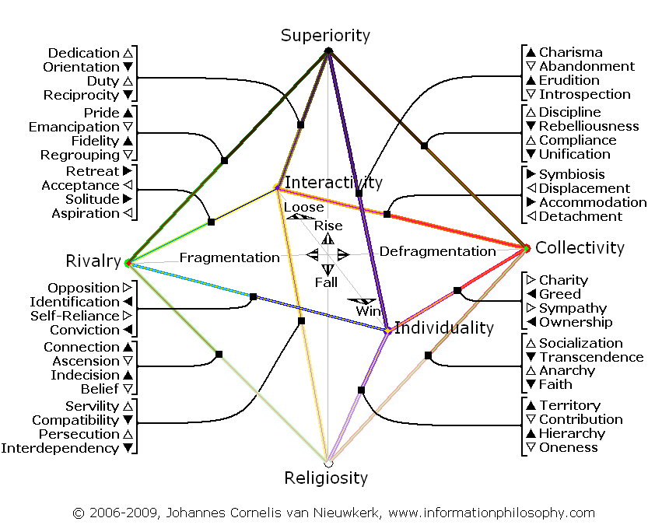

Table 1: 75 relationship scenarios between Arab, Palestinian and Israeli culture
(–/+=Dis/harmonious development. Results:Fat=Harmonic sharing;Underline=Assertive sharing;Italic=Disharm. total)
 | Relationship qualities Arab – Palestinian culture | ID | ID | ID | ID | ID
ID | Origin – Destination from an Arab Cultural Perspective | A | B | C | D | E
1 | Social Control/Compliance –> Social Control/Compliance | 05 | 01 | 09 | 05 | 05
2 | Social Control/Compliance –> Social Unity/Unification + | 01 | 06 | 02 | 01 | 00
3 | Social Control/Compliance –> Democratization/Ownership + | 05 | 00 | 05 | 09 | 05
4 | Social Control/Compliance –> Separation/Detachment + | 09 | 02 | 05 | 05 | 05
5 | Social Control/Compliance –> Worship/Transcendence + | 05 | 01 | 05 | 05 | 09
 | Relationship qualities Palestinian – Arab culture | ID | ID | ID | ID | ID
ID | Origin - Destination from a Palestinian Cultural Perspective | 1 | 2 | 3 | 4 | 5
A | Separation/Detachment –> Separation/Detachment | 05 | 01 | 05 | 09 | 05
B | Separation/Detachment –> Immigration/Accommodation + | 01 | 06 | 00 | 02 | 01
C | Separation/Detachment –> Social Control/Compliance – | 09 | 02 | 05 | 05 | 05
D | Separation/Detachment –> Democratization/Ownership – | 05 | 01 | 09 | 05 | 05
E | Separation/Detachment –> Worship/Transcendence + | 05 | 00 | 05 | 05 | 09

 | Relationship qualities Arab – Israeli culture | ID | ID | ID | ID | ID
ID | Origin - Destination from an Arab Cultural Perspective | F | G | H | I | J
6 | Social Control/Compliance –> Social Control/Compliance | 01 | 01 | 01 | 03 | 01
7 | Social Control/Compliance –> Social Unity/Unification + | 01 | 01 | 03 | 01 | 01
8 | Social Control/Compliance –> Democratization/Ownership + | 04 | 00 | 04 | 07 | 04
9 | Social Control/Compliance –> Separation/Detachment + | 01 | 00 | 01 | 03 | 01
10 | Social Control/Compliance –> Worship/Transcendence + | 01 | 01 | 01 | 03 | 01
 | Relationship qualities Israeli – Arab culture | ID | ID | ID | ID | ID
ID | Origin - Destination from an Israeli Cultural Perspective | 6 | 7 | 8 | 9 | 10
F | Independence/Self-Reliance –> Independence/Self-Reliance | 01 | 01 | 04 | 01 | 01
G | Independence/Self-Reliance –> Discrimination/Conviction – | 01 | 01 | 00 | 00 | 01
H | Independence/Self-Reliance –> Ethics/Introspection – | 01 | 03 | 04 | 01 | 01
I | Independence/Self-Reliance –> Liberalism/Greed + | 03 | 01 | 08 | 03 | 03
J | Independence/Self-Reliance –> Regulation/Territory + | 01 | 01 | 04 | 01 | 01

 | Relationship qualities Palestinian – Israeli culture | ID | ID | ID | ID | ID
ID | Origin - Destination from a Palestinian Cultural Perspective | K | L | M | N | O
11 | Separation/Detachment –> Separation/Detachment | 01 | 00 | 01 | 03 | 01
12 | Separation/Detachment –> Immigration/Accommodation + | 00 | 01 | 00 | 00 | 01
13 | Separation/Detachment –> Social Control/Compliance – | 01 | 01 | 01 | 03 | 01
14 | Separation/Detachment –> Democratization/Ownership – | 04 | 00 | 04 | 07 | 04
15 | Separation/Detachment –> Worship/Transcendence + | 01 | 01 | 01 | 03 | 01
 | Relationship qualities Israeli – Palestinian culture | ID | ID | ID | ID | ID
ID | Origin - Destination from an Israeli Cultural Perspective | 11 | 12 | 13 | 14 | 15
K | Independence/Self-Reliance –> Independence/Self-Reliance | 01 | 00 | 01 | 04 | 01
L | Independence/Self-Reliance –> Discrimination/Conviction – | 00 | 01 | 01 | 00 | 01
M | Independence/Self-Reliance –> Ethics/Introspection – | 01 | 00 | 01 | 04 | 01
N | Independence/Self-Reliance –> Liberalism/Greed + | 03 | 00 | 03 | 08 | 03
O | Independence/Self-Reliance –> Regulation/Territory + | 01 | 01 | 01 | 04 | 01
© 2009, Johannes Cornelis van Nieuwkerk Personal Use Only
Table 2: Institutional relationships between Arab, Palestinian and Israeli culture
(Results: Fat=Harmonic sharing; Underline=Assertive sharing; Italic=Disharmonic total development)
 | Institutional view relationship components Arab – Palestinian culture
ID | A | B |  | C | D |  |  | E
1 | 05 Separation | 01 Employment |  | 09 Social Control | 05 Democratization |  |  | 05 Worship
2 | 01 Trade | 06 Immigration |  | 02 EU-SI | 01 Ethics |  |  | 00 --
3 | 05 Separation | 00 -- |  | 05 Social Control | 09 Democratization |  |  | 05 Worship
4 | 09 Separation | 02 EU-IU |  | 05 Social Control | 05 Democratization |  |  | 05 Worship
5 | 05 Separation | 01 Regard |  | 05 Social Control | 05 Democratization |  |  | 09 Worship
 | Institutional view relationship components Palestinian – Arab culture
ID | 1 |  | 2 | 3 |  | 4 | 5
A | 05 Social Control |  | 01 Resignation | 05 Democratization |  | 09 Separation | 05 Worship
B | 01 Fanaticism |  | 06 Social Unity | 00 -- |  | 02 EU-IU | 01 Harmonization
C | 09 Social Control |  | 02 EU-SI | 05 Democratization |  | 05 Separation | 05 Worship
D | 05 Social Control |  | 01 Capitulation | 09 Democratization |  | 05 Separation | 05 Worship
E | 05 Social Control |  | 00 -- | 05 Democratization |  | 05 Separation | 09 Worship

 | Institutional view relationship components Arab – Israeli culture
ID | F | G | H |  | I |  | J
6 | 01 Liberalism | 01 Rationalization | 01 Greed |  | 03 Democratization |  | 01 Liberalism
7 | 01 Ethics | 01 Morality | 03 Capitulation |  | 01 Ethics |  | 01 Ethics
8 | 04 Independence | 00 -- | 04 Ethics |  | 07 Liberalism |  | 04 Regulation
9 | 01 Liberalism | 00 -- | 01 Liberalism |  | 03 Democratization |  | 01 Liberalism
10 | 01 Liberalism | 01 Contribution | 01 Liberalism |  | 03 Democratization |  | 01 Liberalism
 | Institutional view relationship components Israeli – Arab culture
ID | 6 | 7 | 8 | 9 |  | 10
F | 01 Democratization | 01Capitulation | 04 Liberalism | 01 Democratization |  | 01 Democratization
G | 01 Nazism | 01 Togetherness | 00 -- | 00 -- |  | 01 Meditation
H | 01 Democratization | 03 Revolution | 04 Liberalism | 01 Democratization |  | 01 Democratization
I | 03 Social Control | 01 Capitulation | 08 Democrat. | 03 Separation |  | 03 Worship
J | 01 Democratization | 01 Collectivism | 04 Liberalism | 01 Democratization |  | 01 Democratization

 | Institutional view relationship components Palestinian–Israeli culture
ID | K | L |  | M | N |  | O
11 | 01 Liberalism | 00 -- |  | 01 Liberalism | 03 Democratization |  | 01 Liberalism
12 | 00 -- | 01 Morality |  | 00 -- | 00 -- |  | 01 Prostration
13 | 01 Liberalism | 01 Rationalization |  | 01 Liberalism | 03 Democratization |  | 01 Liberalism
14 | 04 Independence | 00 -- |  | 04 Ethics | 07 Liberalism |  | 04 Democratization
15 | 01 Liberalism | 01 Contemplation |  | 01 Liberalism | 03 Democratization |  | 01 Liberalism
 | Institutional view relationship components Israeli – Palestinian culture
ID | 11 | 12 | 13 |  |  | 14 |  | 15
K | 01 Democratization | 00 -- | 01 Democratization |  |  | 04 Liberalism |  | 01 Democratization
L | 00 -- | 01 Togetherness | 01 Nazism |  |  | 00 -- |  | 01 Meditation
M | 01 Democratization | 00 -- | 01 Democratization |  |  | 04 Liberalism |  | 01 Democratization
N | 03 Separation | 00 -- | 03 Social Control |  |  | 08 Democrat. |  | 03 Worship
O | 01 Democratization | 01 Collectivism | 01 Democratization |  |  | 04 Liberalism |  | 01 Democratization
© 2009, Johannes Cornelis van Nieuwkerk Personal Use Only
Table 3: Personal relationships between Arab, Palestinian and Israeli culture
(Results: Fat=Harmonic sharing; Underline=Assertive sharing; Italic=Disharmonic total development)
 | Personal view relationship components Arab – Palestinian culture
ID | A | B | C | D | E
1 | 05 Detachment | 01 Duty | 09 Compliance | 05 Ownership | 05 Transcendence
2 | 01 Reciprocity | 06 Accommodation | 02 EU-SI | 01 Introspection | 00 --
3 | 05 Detachment | 00 -- | 05 Compliance | 09 Ownership | 05 Transcendence
4 | 09 Detachment | 02 EU-IU | 05 Compliance | 05 Ownership | 05 Transcendence
5 | 05 Detachment | 01 Compatibility | 05 Compliance | 05 Ownership | 09 Transcendence
 | Personal view relationship components Palestinian – Arab culture
ID | 1 | 2 | 3 | 4 | 5
A | 05 Compliance | 01 Orientation | 05 Ownership | 09 Detachment | 05 Transcendence
B | 01 Dedication | 06 Unification | 00 -- | 02 EU-IU | 01 Interdependency
C | 09 Compliance | 02 EU-SI | 05 Ownership | 05 Detachment | 05 Transcendence
D | 05 Compliance | 01 Abandonment | 09 Ownership | 05 Detachment | 05 Transcendence
E | 05 Compliance | 00 -- | 05 Ownership | 05 Detachment | 09 Transcendence

 | Personal view relationship components Arab – Israeli culture
ID | F |  | G | H | I |  | J
6 | 01 Greed |  | 01 Erudition | 01 Greed | 03 Ownership |  | 01 Greed
7 | 01 Introspection |  | 01 Charity | 03 Abandonment | 01 Introspection |  | 01 Introspection
8 | 04 Self-Reliance |  | 00 -- | 04 Introspection | 07 Greed |  | 04 Territory
9 | 01 Greed |  | 00 -- | 01 Greed | 03 Ownership |  | 01 Greed
10 | 01 Greed |  | 01 Contribution | 01 Greed | 03 Ownership |  | 01 Greed
 | Personal view relationship components Israeli – Arab culture
ID | 6 | 7 |  | 8 | 9 | 10
F | 01 Ownership | 01Abandonment |  | 04 Greed | 01 Ownership | 01 Ownership
G | 01 Charisma | 01 Sympathy |  | 00 -- | 00 -- | 01 Oneness
H | 01 Ownership | 03 Rebelliousness |  | 04 Greed | 01 Ownership | 01 Ownership
I | 03 Compliance | 01 Abandonment |  | 08 Ownership | 03 Detachment | 03 Transcendence
J | 01 Ownership | 01 Socialization |  | 04 Greed | 01 Ownership | 01 Ownership

 | Personal view relationship components Palestinian–Israeli culture
ID | K |  | L | M | N |  | O
11 | 01 Greed |  | 00 -- | 01 Greed | 03 Ownership |  | 01 Greed
12 | 00 -- |  | 01 Charity | 00 -- | 00 -- |  | 01 Anarchy
13 | 01 Greed |  | 01 Erudition | 01 Greed | 03 Ownership |  | 01 Greed
14 | 04 Self-Reliance |  | 00 -- | 04 Introspection | 07 Greed |  | 04 Territory
15 | 01 Greed |  | 01 Contribution | 01 Greed | 03 Ownership |  | 01 Greed
 | Personal view relationship components Israeli – Palestinian culture
ID | 11 | 12 |  | 13 | 14 | 15
K | 01 Ownership | 00 -- |  | 01 Ownership | 04 Greed | 01 Ownership
L | 00 -- | 01 Sympathy |  | 01 Charisma | 00 -- | 01 Oneness
M | 01 Ownership | 00 -- |  | 01 Ownership | 04 Greed | 01 Ownership
N | 03 Detachment | 00 -- |  | 03 Compliance | 08 Ownership | 03 Transcendence
O | 01 Ownership | 01 Socialization |  | 01 Ownership | 04 Greed | 01 Ownership
© 2009, Johannes Cornelis van Nieuwkerk Personal Use Only
Table 4: Institutional improvement between Arab, Palestinian and Israeli culture
(Results: Fat=Harmonic sharing; Underline=Assertive sharing; Italic=Disharmonic total development)
 | Institutional view relationship components Arab – Palestinian culture
ID | A | B |  | C | D |  |  | E
1 |  |  |  | 09 Social Control
2 |  | 06 Immigration
3 |  |  |  |  | 09 Democratization
4 | 09 Separation
5 |  |  |  |  |  |  |  | 09 Worship
 | Institutional view relationship components Palestinian – Arab culture
ID | 1 |  | 2 | 3 |  | 4 | 5
A |  |  |  |  |  | 09 Separation
B |  |  | 06 Social Unity
C | 09 Social Control
D |  |  |  | 09 Democratization
E |  |  |  |  |  |  | 09 Worship

 | Institutional view relationship components Arab – Israeli culture
ID | F | G | H |  | I |  | J
6 |  |  |  |  | 03 Democratization
7 |  |  | 03 Capitulation
8 | 04 Independence |  | 04 Ethics |  | 07 Liberalism |  | 04 Regulation
9 |  |  |  |  | 03 Democratization
10 |  |  |  |  | 03 Democratization
 | Institutional view relationship components Israeli – Arab culture
ID | 6 | 7 | 8 | 9 |  | 10
F |  |  | 04 Liberalism
G
H |  | 03 Revolution | 04 Liberalism
I | 03 Social Control |  | 08 Democrat. | 03 Separation |  | 03 Worship
J |  |  | 04 Liberalism

 | Institutional view relationship components Palestinian–Israeli culture
ID | K | L |  | M | N |  | O
11 |  |  |  |  | 03 Democratization
12
13 |  |  |  |  | 03 Democratization
14 | 04 Independence |  |  | 04 Ethics | 07 Liberalism |  | 04 Democratization
15 |  |  |  |  | 03 Democratization
 | Institutional view relationship components Israeli – Palestinian culture
ID | 11 | 12 | 13 |  |  | 14 |  | 15
K |  |  |  |  |  | 04 Liberalism
L
M |  |  |  |  |  | 04 Liberalism
N | 03 Separation |  | 03 Social Control |  |  | 08 Democrat. |  | 03 Worship
O |  |  |  |  |  | 04 Liberalism
© 2009, Johannes Cornelis van Nieuwkerk Personal Use Only
Table 5: Personal improvement between Arab, Palestinian and Israeli culture
(Results: Fat=Harmonic sharing; Underline=Assertive sharing; Italic=Disharmonic total development)
 | Personal view relationship components Arab – Palestinian culture
ID | A | B | C | D | E
1 |  |  | 09 Compliance
2 |  | 06 Accommodation
3 |  |  |  | 09 Ownership
4 | 09 Detachment
5 |  |  |  |  | 09 Transcendence
 | Personal view relationship components Palestinian – Arab culture
ID | 1 | 2 | 3 | 4 | 5
A |  |  |  | 09 Detachment
B |  | 06 Unification
C | 09 Compliance
D |  |  | 09 Ownership
E |  |  |  |  | 09 Transcendence

 | Personal view relationship components Arab – Israeli culture
ID | F |  | G | H | I |  | J
6 |  |  |  |  | 03 Ownership
7 |  |  |  | 03 Abandonment
8 | 04 Self-Reliance |  |  | 04 Introspection | 07 Greed |  | 04 Territory
9 |  |  |  |  | 03 Ownership
10 |  |  |  |  | 03 Ownership
 | Personal view relationship components Israeli – Arab culture
ID | 6 | 7 |  | 8 | 9 | 10
F |  |  |  | 04 Greed
G
H |  | 03 Rebelliousness |  | 04 Greed
I | 03 Compliance |  |  | 08 Ownership | 03 Detachment | 03 Transcendence
J |  |  |  | 04 Greed

 | Personal view relationship components Palestinian–Israeli culture
ID | K |  | L | M | N |  | O
11 |  |  |  |  | 03 Ownership
12
13 |  |  |  |  | 03 Ownership
14 | 04 Self-Reliance |  |  | 04 Introspection | 07 Greed |  | 04 Territory
15 |  |  |  |  | 03 Ownership
 | Personal view relationship components Israeli – Palestinian culture
ID | 11 | 12 |  | 13 | 14 | 15
K |  |  |  |  | 04 Greed
L
M |  |  |  |  | 04 Greed
N | 03 Detachment |  |  | 03 Compliance | 08 Ownership | 03 Transcendence
O |  |  |  |  | 04 Greed
© 2009, Johannes Cornelis van Nieuwkerk Personal Use Only
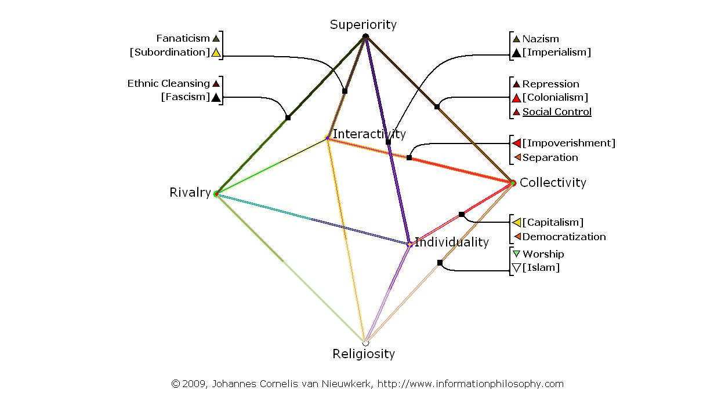
Map 37 (-1- 1C) Arab Culture, Social Control, 09 Social Control, Institutional View:

Map 38 (-1- C1) Palestinian Culture, Social Control, 09 Social Control, Institutional View:

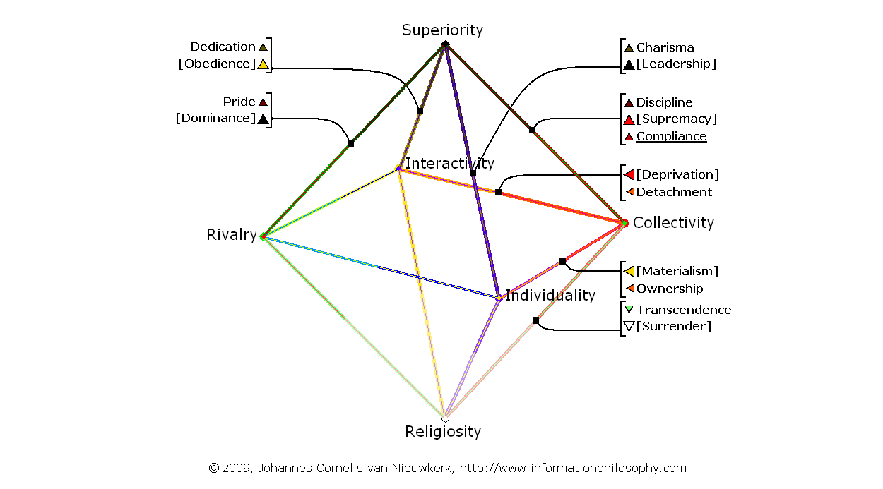
Map 39 (-1- 1C) Arab Culture, Compliance, 09 Compliance, Personal View:

Map 40 (-1- C1) Palestinian Culture, Compliance, 09 Compliance, Personal View:

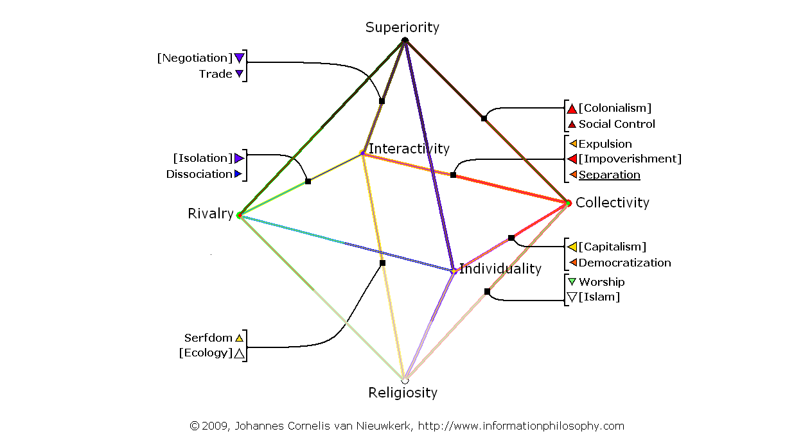
Map 41 (-2- 4A) Arab Culture, Separation, 09 Separation, Institutional View:

Map 42 (-2- A4) Palestinian Culture, Separation, 09 Separation, Institutional View:

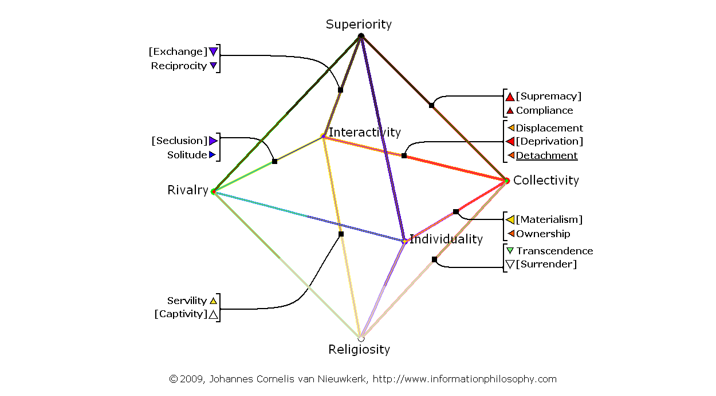
Map 43 (-2- 4A) Arab Culture, Detachment, 09 Detachment, Personal View:

Map 44 (-2- A4) Palestinian Culture, Detachment, 09 Detachment, Personal View:

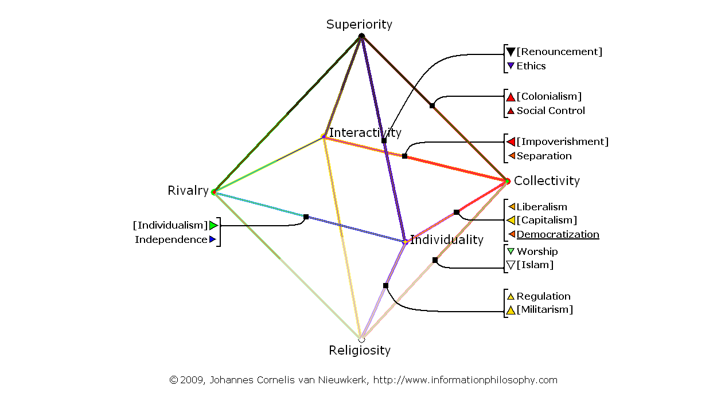
Map 45 (-3- 3D) Arab Culture, Democratization, 09 Democratization, Institutional View:

Map 46 (-3- D3) Palestinian Culture, Democratization, 09 Democratization, Instit. View:

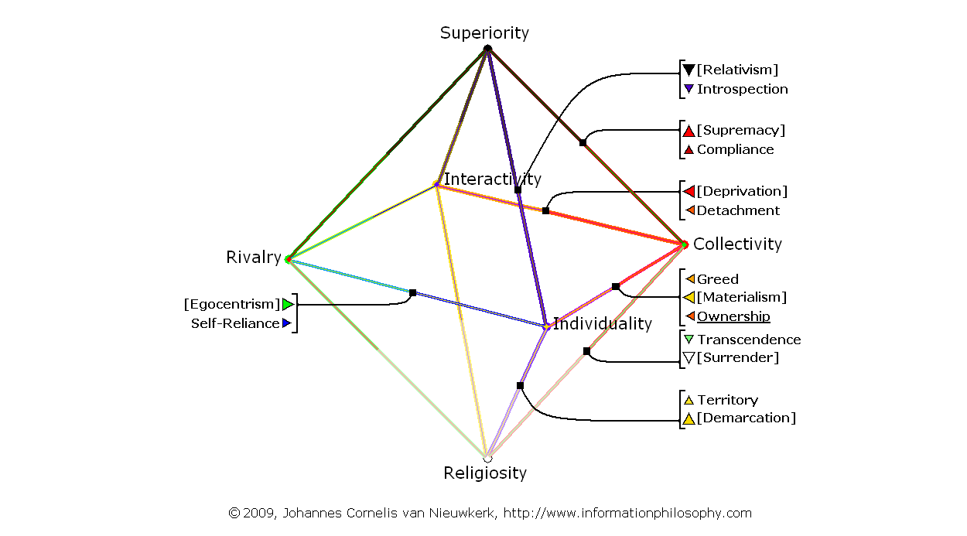
Map 47 (-3- 3D) Arab Culture, Ownership, 09 Ownership, Personal View:

Map 48 (-3- D3) Palestinian Culture, Ownership, 09 Ownership, Personal View:

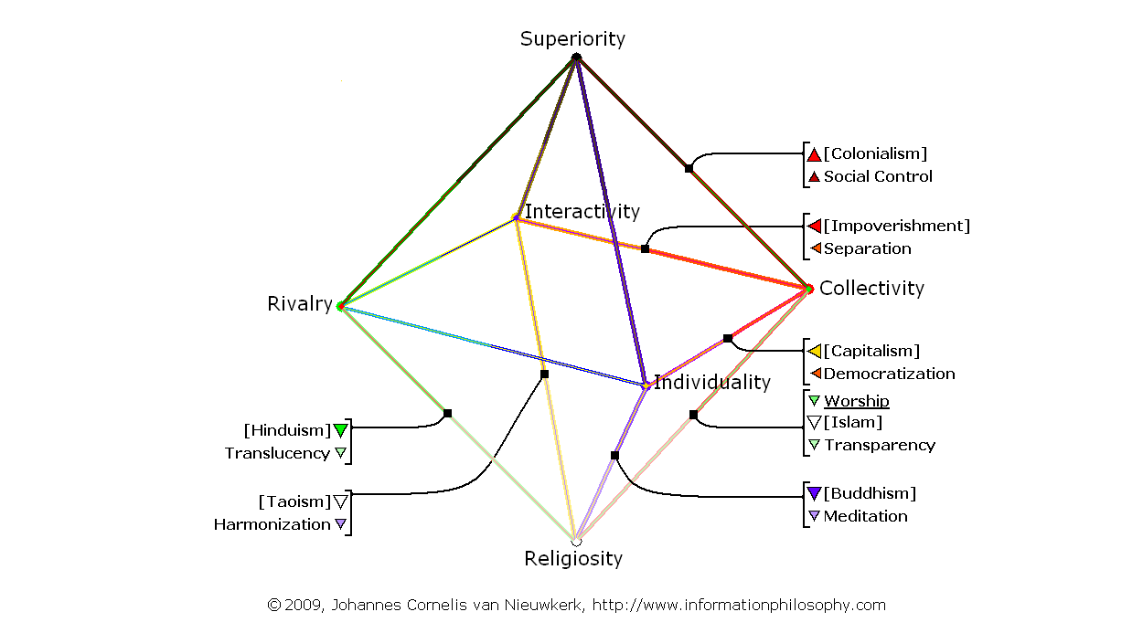
Map 49 (-4- 5E) Arab Culture, Worship, 09 Worship, Institutional View:

Map 50 (-4- E5) Palestinian Culture, Worship, 09 Worship, Institutional View:

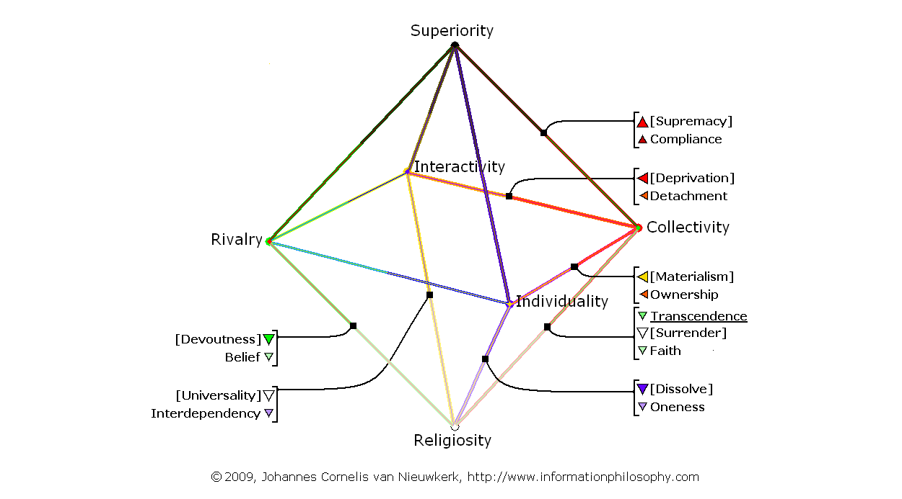
Map 51 (-4- 5E) Arab Culture, Transcendence, 09 Transcendence, Personal View:

Map 52 (-4- E5) Palestinian Culture, Transcendence, 09 Transcendence, Personal View:

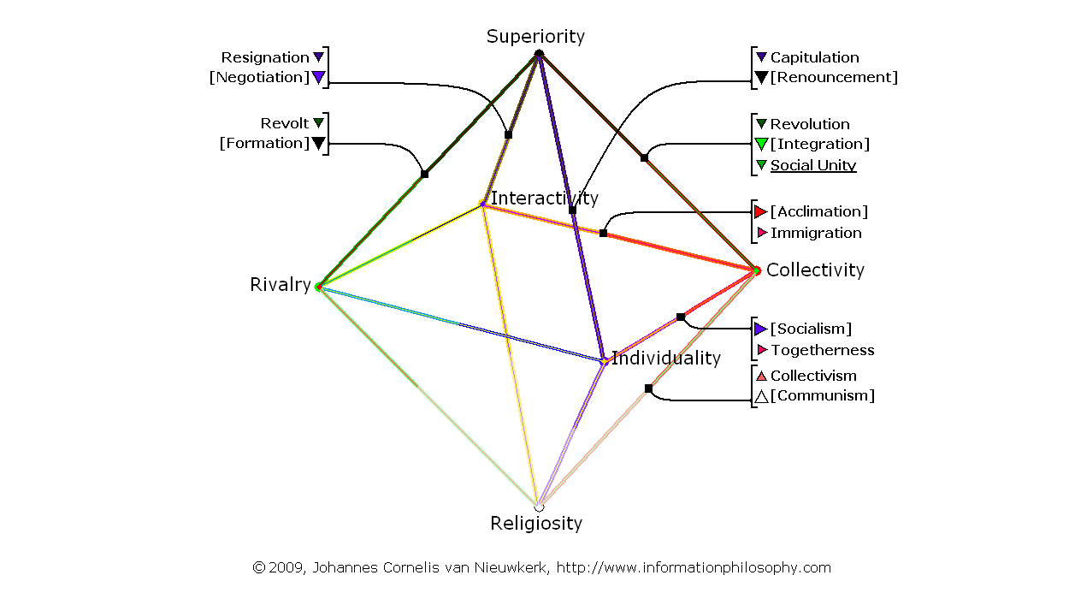
Map 53 (-5- 2B) Arab Culture, Social Unity, 06 Immigration, Institutional View:

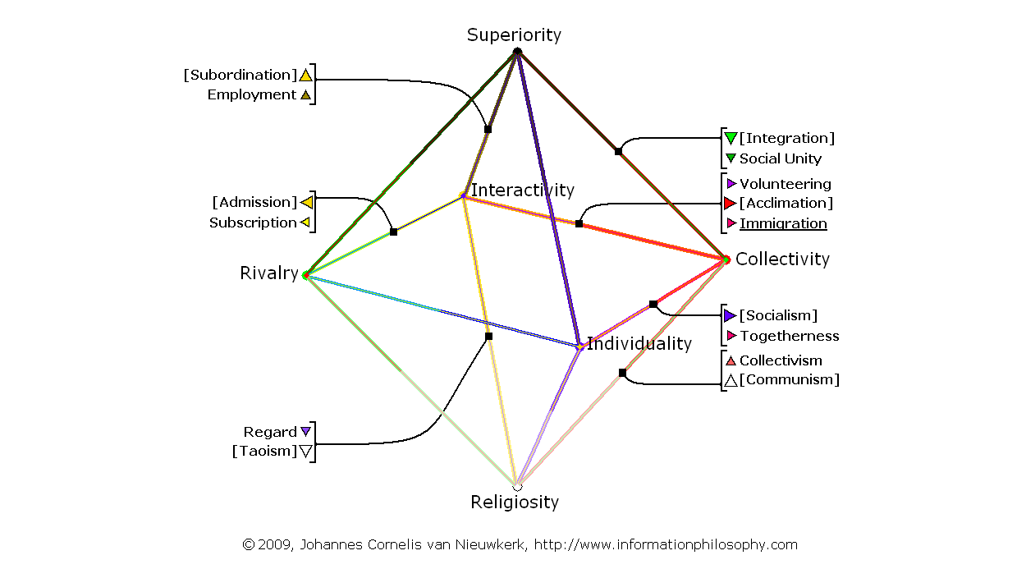
Map 54 (-5- B2) Palestinian Culture, Immigration, 06 Social Unity, Institutional View:

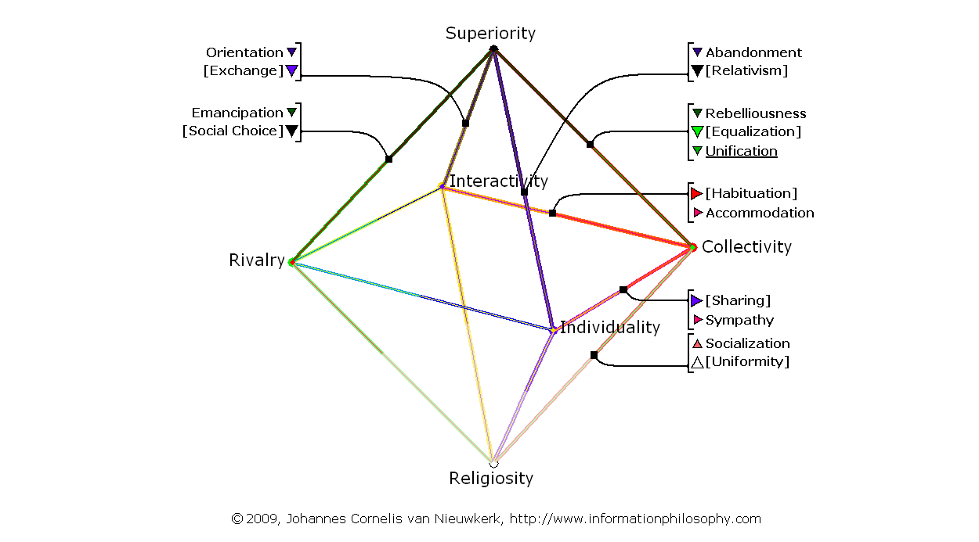
Map 55 (-5- 2B) Arab Culture, Unification, 06 Accommodation, Personal View:

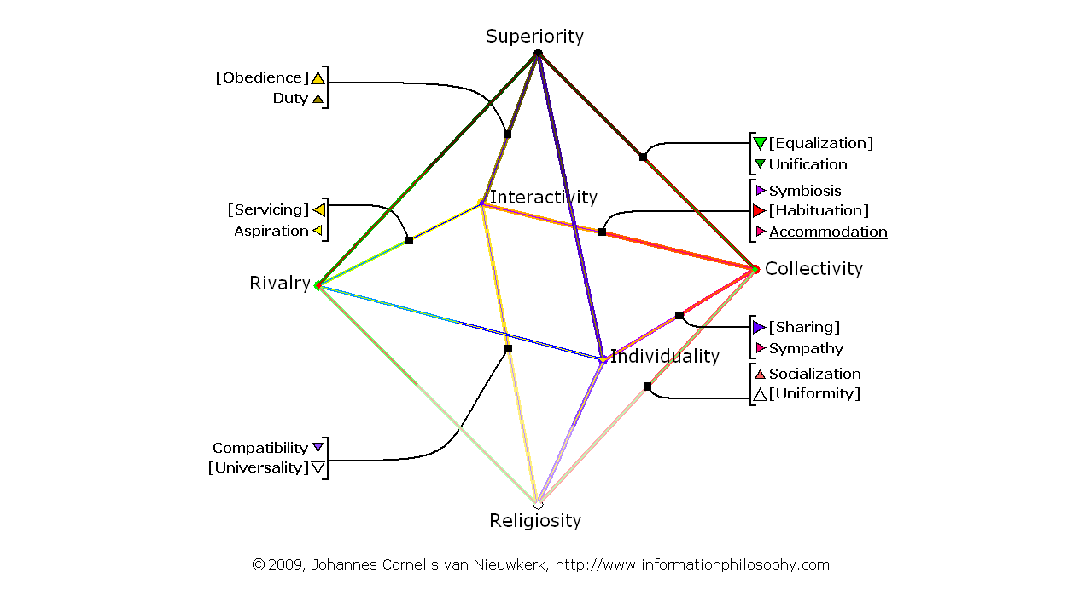
Map 56 (-5- B2) Palestinian Culture, Accommodation, 06 Unification, Personal View:

Map 57 (-1- 8I) Arab Culture, Democratization, 07 Liberalism, Institutional View:

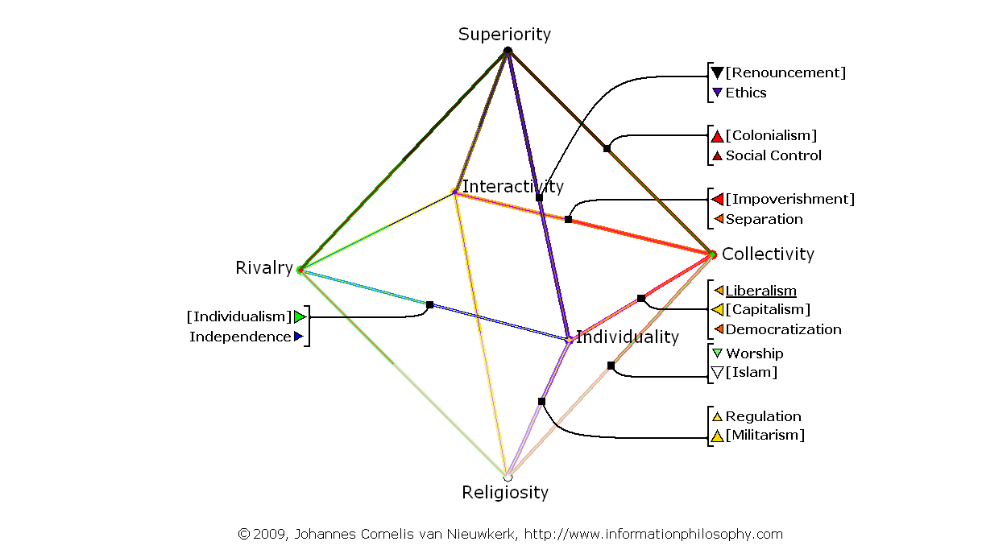
Map 58 (-1- I8) Israeli Culture, Liberalism, 08 Democratization, Institutional View:

Map 59 (-1- 8I) Arab Culture, Ownership, 07 Greed, Personal View:

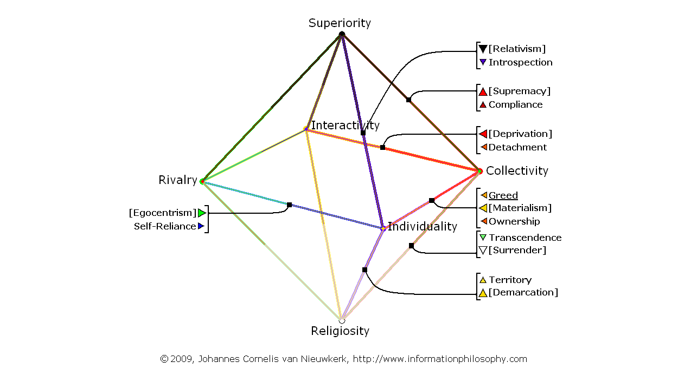
Map 60 (-1- I8) Israeli Culture, Greed, 08 Ownership, Personal View:

Map 61 (-2- 8F) Arab Culture, Democratization, 04 Independence, Institutional View:

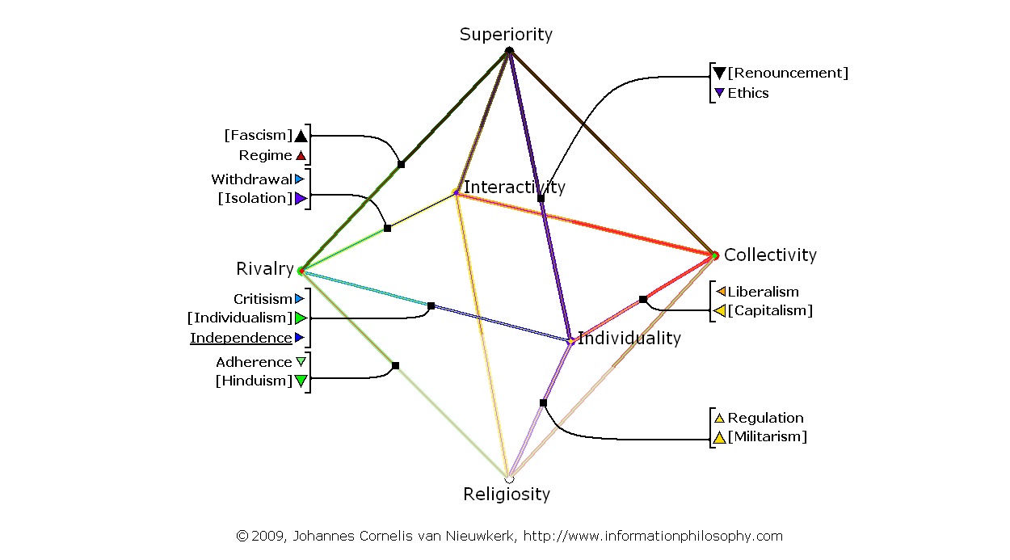
Map 62 (-2- F8) Israeli Culture, Independence, 04 Liberalism, Institutional View:

Map 63 (-2- 8F) Arab Culture, Ownership, 04 Self-Reliance, Personal View:

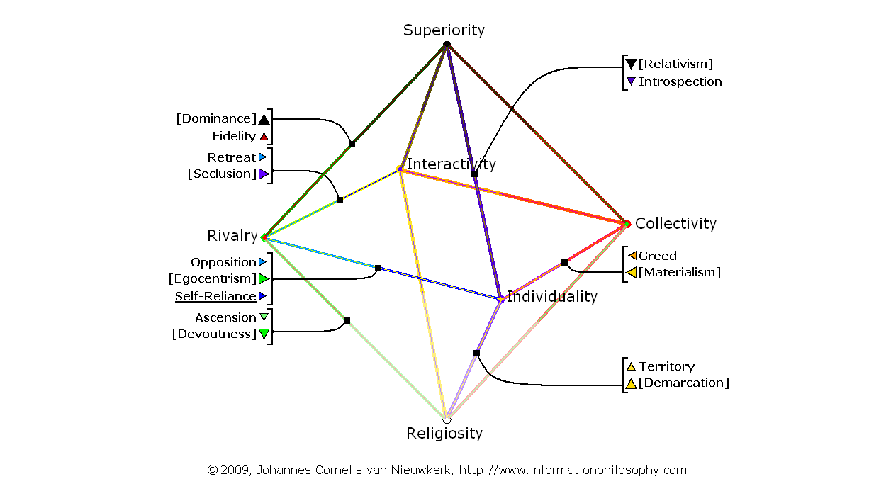
Map 64 (-2- F8) Israeli Culture, Self-Reliance, 04 Greed, Personal View:

Map 65 (-3- 6I) Arab Culture, Social Control, 03 Democratization, Institutional View:

Map 66 (-3- I6) Israeli Culture, Liberalism, 03 Social Control, Institutional View:

Map 67 (-3- 6I) Arab Culture, Compliance, 03 Ownership, Personal View:

Map 68 (-3- I6) Israeli Culture, Greed, 03 Compliance, Personal View:

Map 69 (-4- 8H) Arab Culture, Democratization, 04 Ethics, Institutional View:

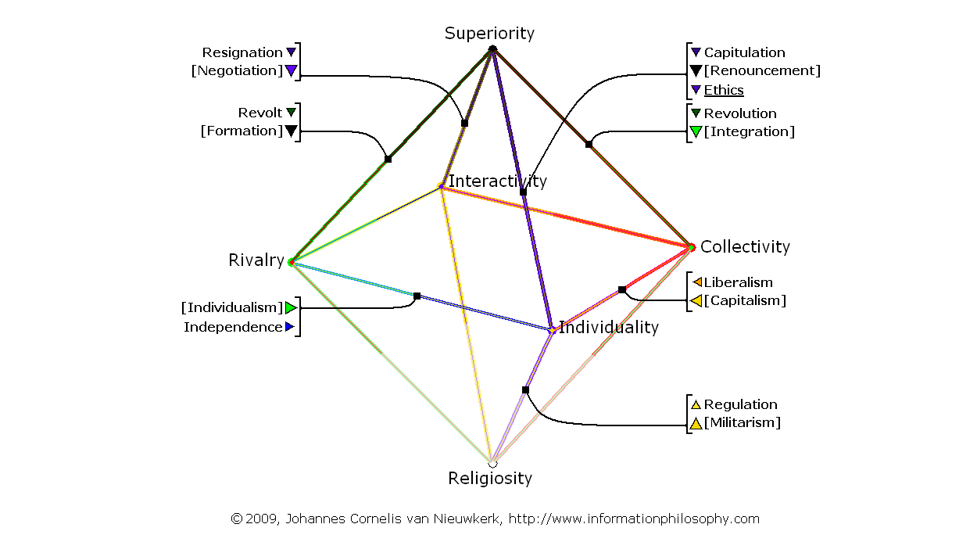
Map 70 (-4- H8) Israeli Culture, Ethics, 04 Liberalism, Institutional View:

Map 71 (-4- 8H) Arab Culture, Ownership, 04 Introspection, Personal View:

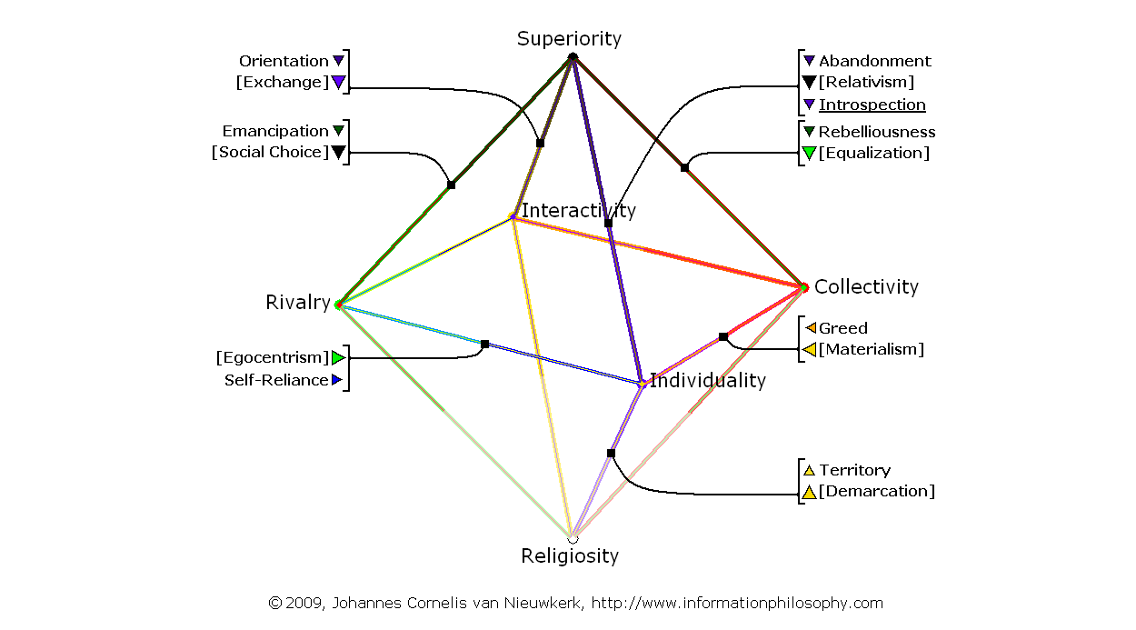
Map 72 (-4- H8) Israeli Culture, Introspection, 04 Greed, Personal View:

Map 73 (-5- 8J) Arab Culture, Democratization, 04 Regulation, Institutional View:

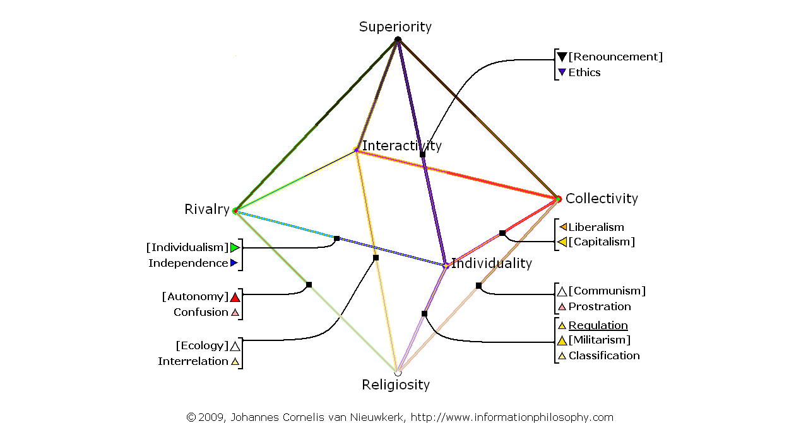
Map 74 (-5- J8) Israeli Culture, Regulation, 04 Liberalism, Institutional View:

Map 75 (-5- 8J) Arab Culture, Ownership, 04 Territory, Personal View:

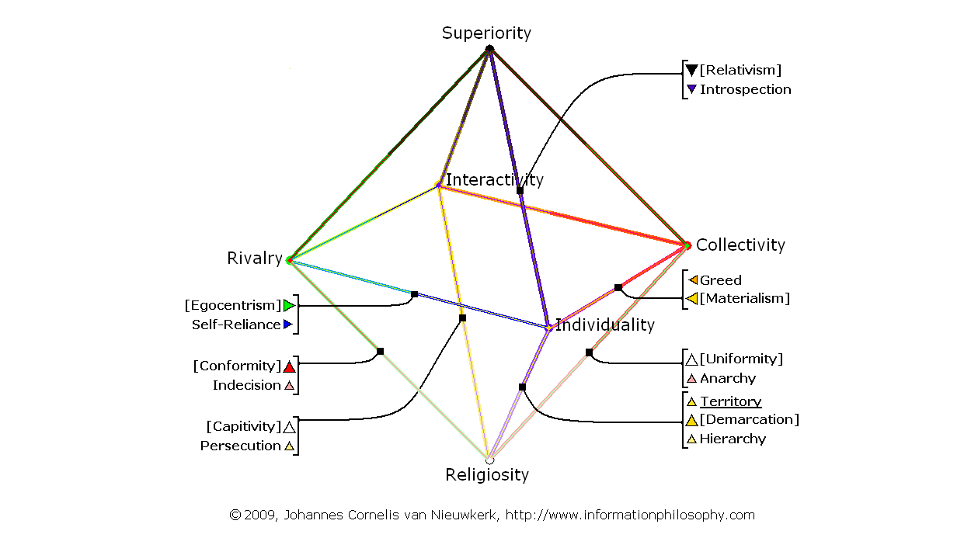
Map 76 (-5- J8) Israeli Culture, Territory, 04 Greed, Personal View:

Map 77 (-6- 9I) Arab Culture, Separation, 03 Democratization, Institutional View:

Map 78 (-6- I9) Israeli Culture, Liberalism, 03 Separation, Institutional View:

Map 79 (-6- 9I) Arab Culture, Detachment, 03 Ownership, Personal View:

Map 80 (-6- I9) Israeli Culture, Greed, 03 Detachment, Personal View:

Map 81 (-7- 10I) Arab Culture, Worship, 03 Democratization, Institutional View:

Map 82 (-7- I10) Israeli Culture, Liberalism, 03 Worship, Institutional View:

Map 83 (-7- 10I) Arab Culture, Transcendence, 03 Ownership, Personal View:

Map 84 (-7- I10) Israeli Culture, Greed, 03 Transcendence, Personal View:

Map 85 (-8- 7H) Arab Culture, Social Unity, 03 Capitulation, Institutional View:

Map 86 (-8- H7) Israeli Culture, Ethics, 03 Revolution, Institutional View:

Map 87 (-8- 7H) Arab Culture, Unification, 03 Abandonment, Personal View:

Map 88 (-8- H7) Israeli Culture, Introspection, 03 Rebelliousness, Personal View:

Map 89 (-1- 14N) Palestinian Culture, Democratization, 07 Liberalism, Institutional View:

Map 90 (-1- N14) Israeli Culture, Liberalism, 08 Democratization, Institutional View:

Map 91 (-1- 14N) Palestinian Culture, Ownership, 07 Greed, Personal View:

Map 92 (-1- N14) Israeli Culture, Greed, 08 Ownership, Personal View:

Map 93 (-2- 14K) Palestinian Culture, Democratization, 04 Independence, Instit. View:

Map 94 (-2- K14) Israeli Culture, Independence, 04 Liberalism, Institutional View:

Map 95 (-2- 14K) Palestinian Culture, Ownership, 04 Self-Reliance, Personal View:

Map 96 (-2- K14) Israeli Culture, Self-Reliance, 04 Greed, Personal View:

Map 97 (-3- 11N) Palestinian Culture, Separation, 03 Democratization, Institutional View:

Map 98 (-3- N11) Israeli Culture, Liberalism, 03 Separation, Institutional View:

Map 99 (-3- 11N) Palestinian Culture, Detachment, 03 Ownership, Personal View:

Map 100 (-3- N11) Israeli Culture, Greed, 03 Detachment, Personal View:

Map 101 (-4- 14M) Palestinian Culture, Democratization, 04 Ethics, Institutional View:

Map 102 (-4- M14) Israeli Culture, Ethics, 04 Liberalism, Institutional View:

Map 103 (-4- 14M) Palestinian Culture, Ownership, 04 Introspection, Personal View:

Map 104 (-4- M14) Israeli Culture, Introspection, 04 Greed, Personal View:

Map 105 (-5- 14O) Palestinian Culture, Democratization, 04 Regulation, Instit. View:

Map 106 (-5- O14) Israeli Culture, Regulation, 04 Liberalism, Institutional View:

Map 107 (-5- 14O) Palestinian Culture, Ownership, 04 Territory, Personal View:

Map 108 (-5- O14) Israeli Culture, Territory, 04 Greed, Personal View:

Map 109 (-6- 13N) Palestinian Culture, Social Control, 03 Democratization, Instit. View:

Map 110 (-6- N13) Israeli Culture, Liberalism, 03 Social Control, Institutional View:

Map 111 (-6- 13N) Palestinian Culture, Compliance, 03 Ownership, Personal View:

Map 112 (-6- N13) Israeli Culture, Greed, 03 Compliance, Personal View:

Map 113 (-7- 15N) Palestinian Culture, Worship, 03 Democratization, Institutional View:

Map 114 (-7- N15) Israeli Culture, Liberalism, 03 Worship, Institutional View:

Map 115 (-7- 15N) Palestinian Culture, Transcendence, 03 Ownership, Personal View:

Map 116 (-7- N15) Israeli Culture, Greed, 03 Transcendence, Personal View:

